**e – Recruitment Management System (e-RMS)**

**INTRODUCTION**

The recruitment process in India is a continuous endeavor, with various government departments conducting annual drives to fill vacant positions. Managing the applications of millions of candidates participating in these recruitment exercises presents a significant administrative challenge.

As of 2025, the demand for government jobs remains exceptionally high. For instance, the Railway Recruitment Board's Non-Technical Popular Categories (RRB NTPC) 2025 recruitment attracted over 1.21 crore applicants competing for 11,558 vacancies, highlighting the intense competition for limited positions.**1** Similarly, the Staff Selection Commission's General Duty (SSC GD) Constable recruitment for 2025 announced 53,690 vacancies, marking it as one of the largest in recent years.**2**

Despite the overwhelming interest, a significant number of positions remain unfilled across various government sectors. For example, in Andhra Pradesh, the District Selection Committee (DSC) 2025 teacher recruitment saw 3.35 lakh candidates applying for 16,347 teaching posts, averaging about 35 applicants per post.**3**

Many government institutions continue to rely on traditional methods for handling recruitment notices physically. While some have transitioned to semi-digital application processes, tasks such as processing results and issuing appointment letters are still carried out manually. This reliance on physical processing leads to challenges and losses for all parties involved. For instance, once a provisional appointment letter is issued, it typically takes 10-15 days to reach the recipient. In some cases, the letter may be lost in transit, potentially resulting in the cancellation of the appointment.

India has a significant unemployed population actively seeking job opportunities, yet many positions in government agencies remain unfilled. This issue arises partly due to the lack of a structured waiting list for qualified candidates who missed appointments due to intense competition. The offline recruitment management system further exacerbates the problem by lacking the efficiency and transparency needed to address such gaps effectively.

The e-Recruitment Management System aims to address the limitations of the traditional, physical recruitment process. It will feature modules for receiving applications, processing results, and automating the allotment of vacancies based on the specific criteria outlined in each recruitment notice.

This system benefits both key stakeholders in the recruitment process: the appointee and the appointer. Candidates can register on the system to view all open recruitment notices and apply directly. Recruiters, on the other hand, can create recruitment notices, enter candidates' results, and let the system automatically sort and generate a rank list. Once the rank list is prepared, recruiters can send appointment letters to selected candidates. Candidates can then accept or reject the offer through the system. If an offer is rejected, the recruiter can seamlessly issue an appointment letter to the next eligible candidate on the rank list.

By streamlining the recruitment process, the e-Recruitment Management System aims to significantly reduce delays and inefficiencies. Addressing the issue of repeated vacancies in certain offices enhances the effectiveness of the recruitment cycle. Additionally, the system promotes the judicious use of resources while improving operational efficiency and ensuring greater transparency in the hiring process.

**OBJECTIVES**

* **Digitize and Streamline Recruitment Process**

Replace traditional, paper-based recruitment methods with an end-to-end digital system that handles everything from application submission to result processing and appointment letter issuance.

* **Reduce Delays and Prevent Appointment Failures**

To minimize delays in communication (e.g., postal appointment letters) and reduce the risk of offer cancellations by enabling instant, trackable offer acceptance or rejection within the system.

* **Optimize Vacancy Utilization**

To ensure efficient use of available vacancies by automatically maintaining a ranked waiting list of eligible candidates, enabling quick reallocation if an offer is declined.

* **Improve Transparency and Efficiency**

To enhance the transparency and accountability of government recruitment by providing both recruiters and applicants real-time access to recruitment statuses, result rankings, and appointment decisions.

**TOOLS / ENVIRONMENT USED**

**Software**

* Front End: HTML / CSS / Bootstrap / JavaScript (React.js)
* Back End: PHP / MySQL

**Development**

* Visual Studio Code (Source Code Editor)
* Git (Version control)
* GitHub (Remote repository hosting)

**Other Tools**

* Figma (UI Design)
* Lucidchart (Diagram)

**ANALYSIS**

**System Requirements Specification**

**CODE**

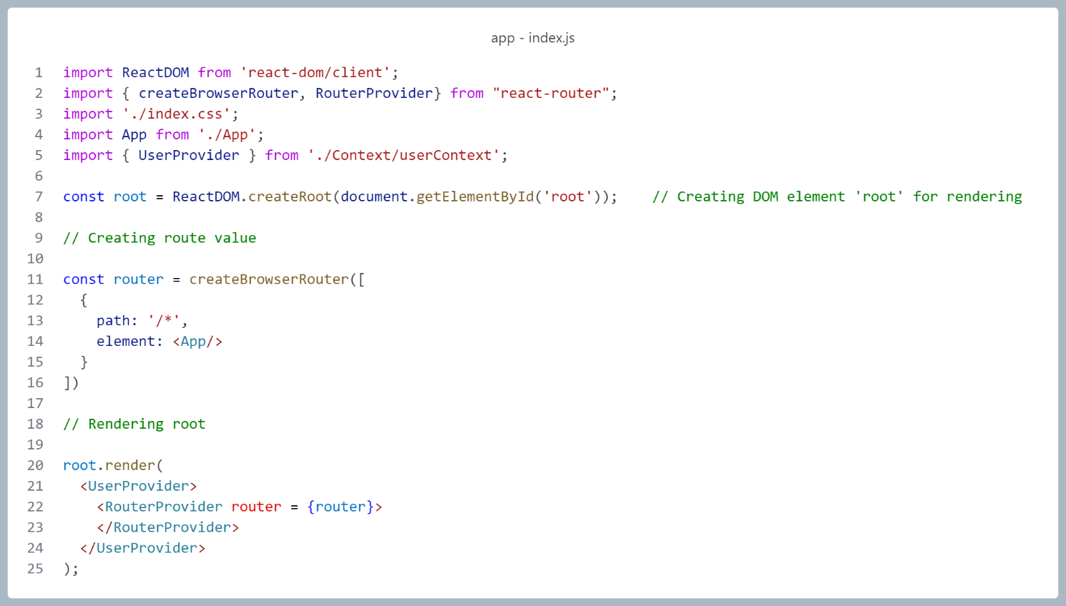

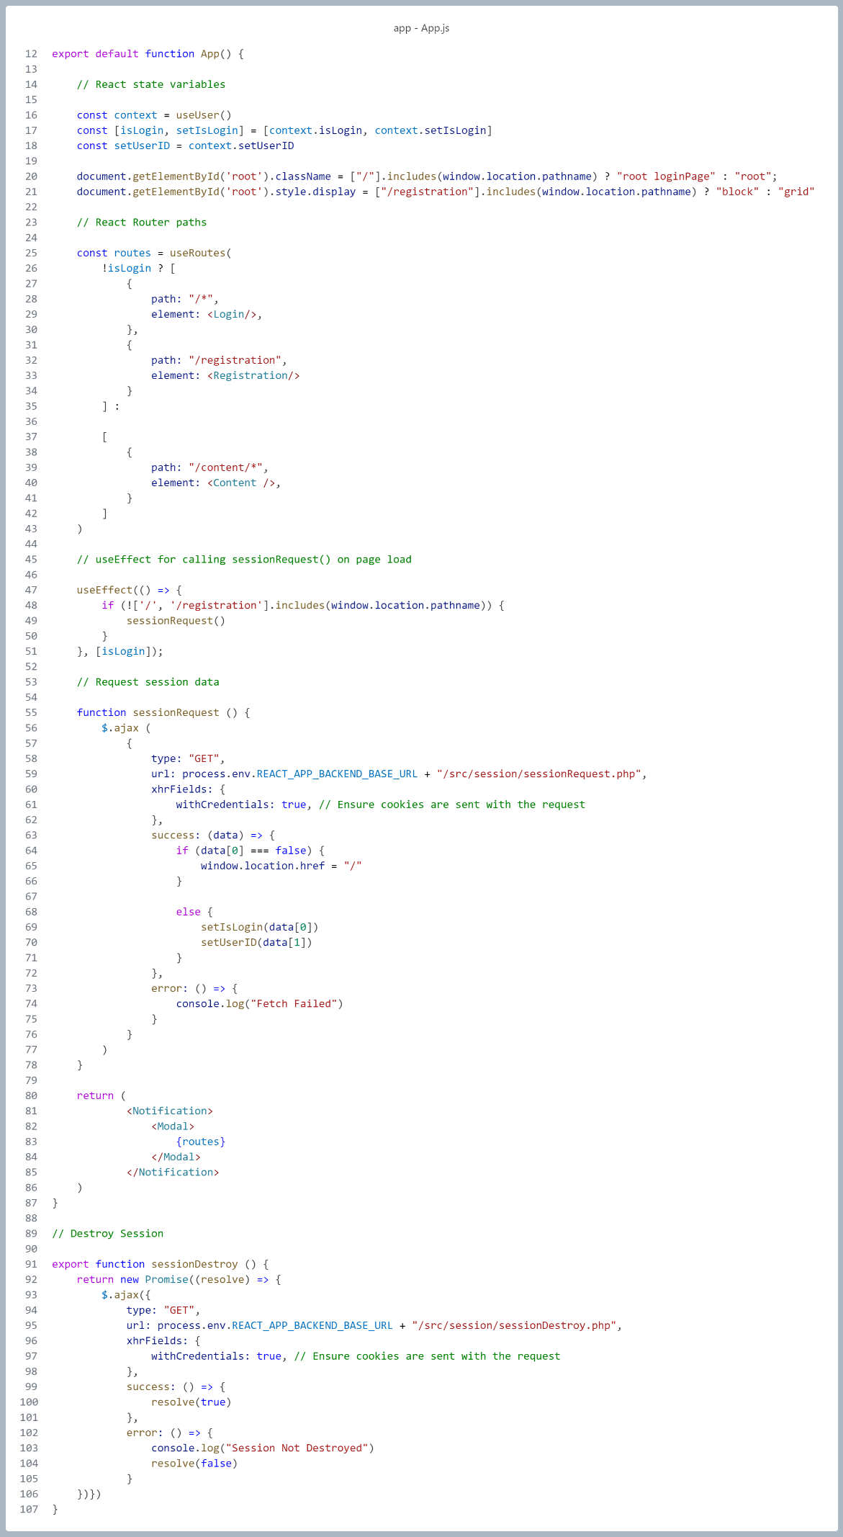

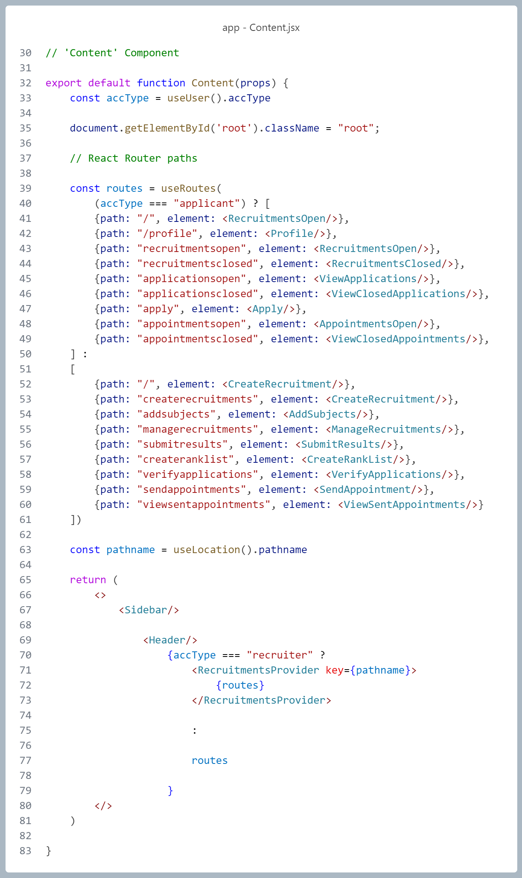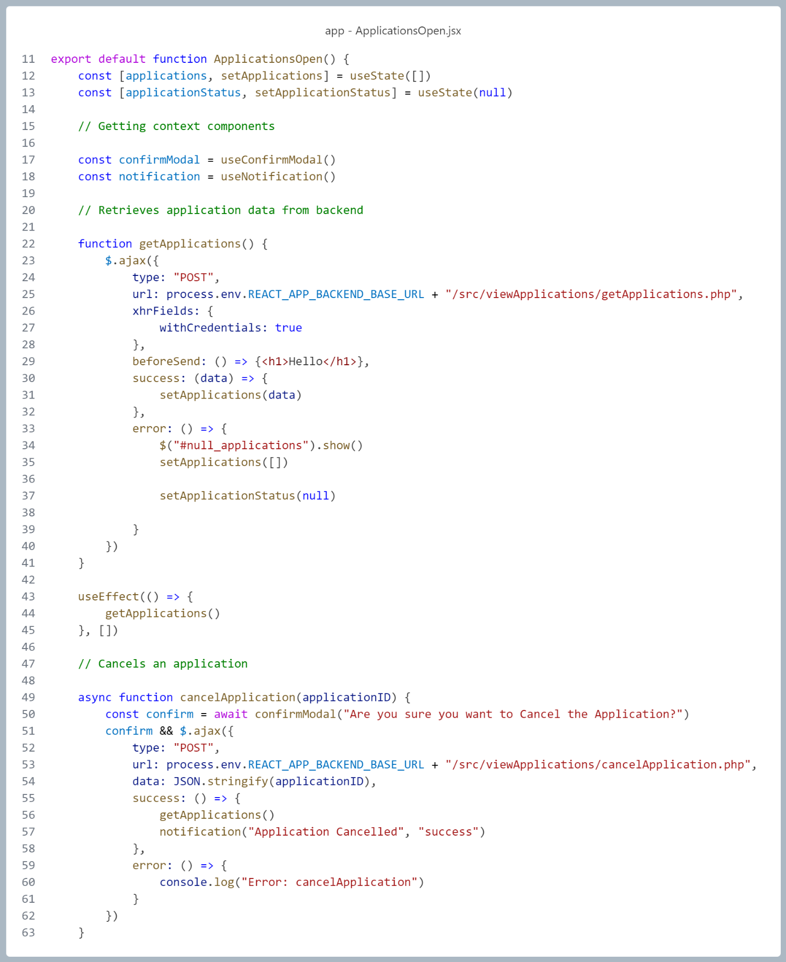

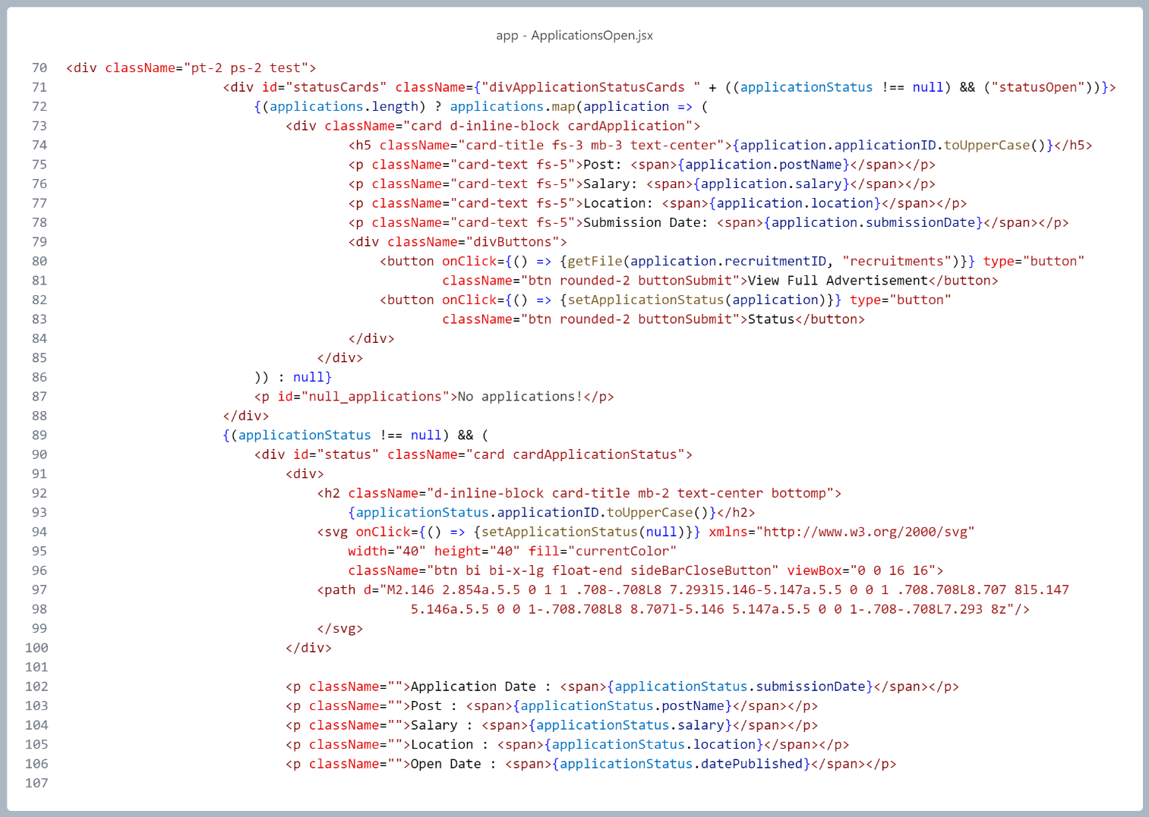

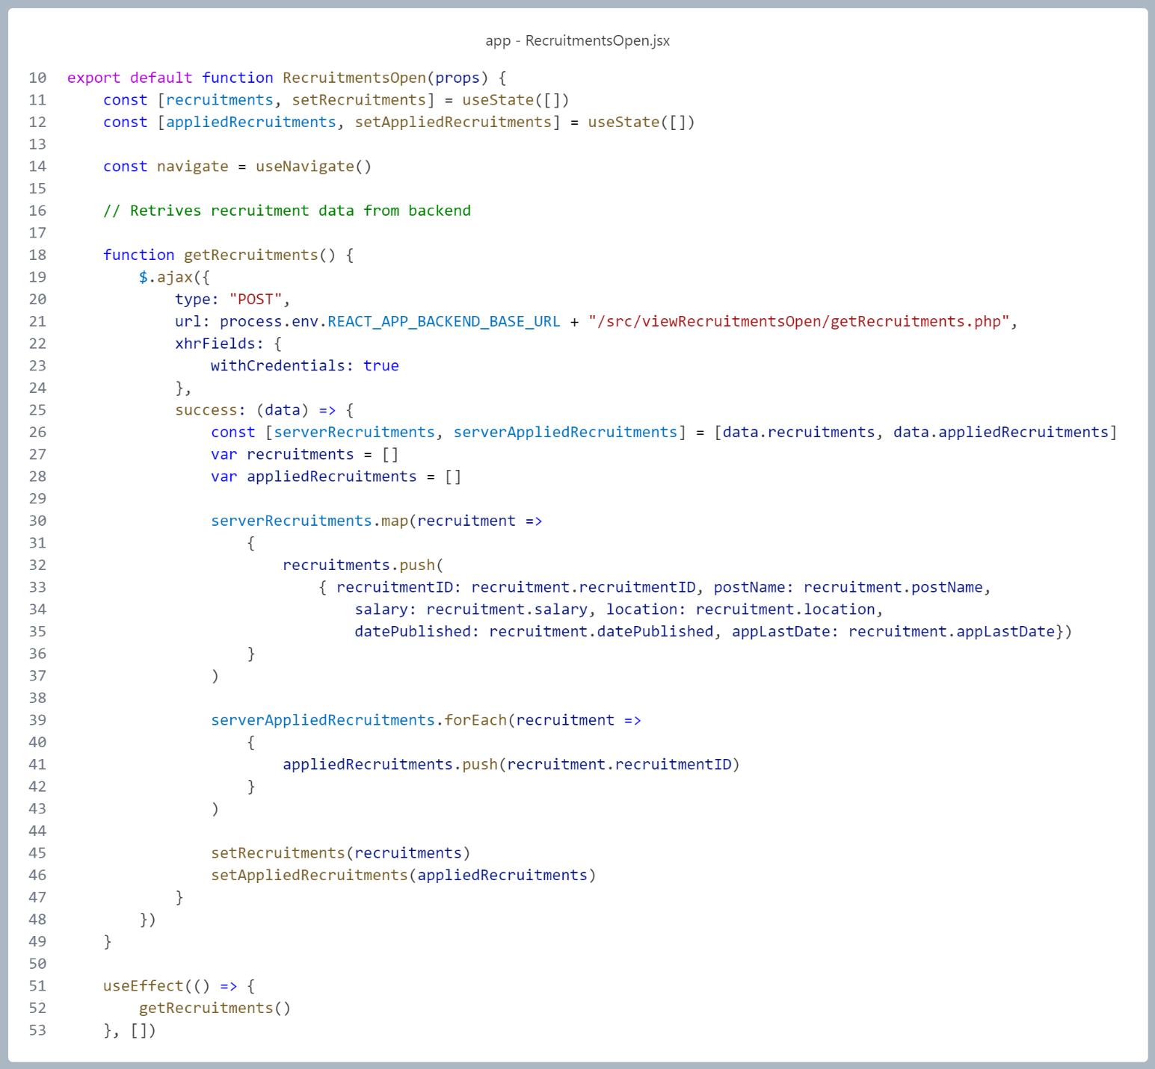

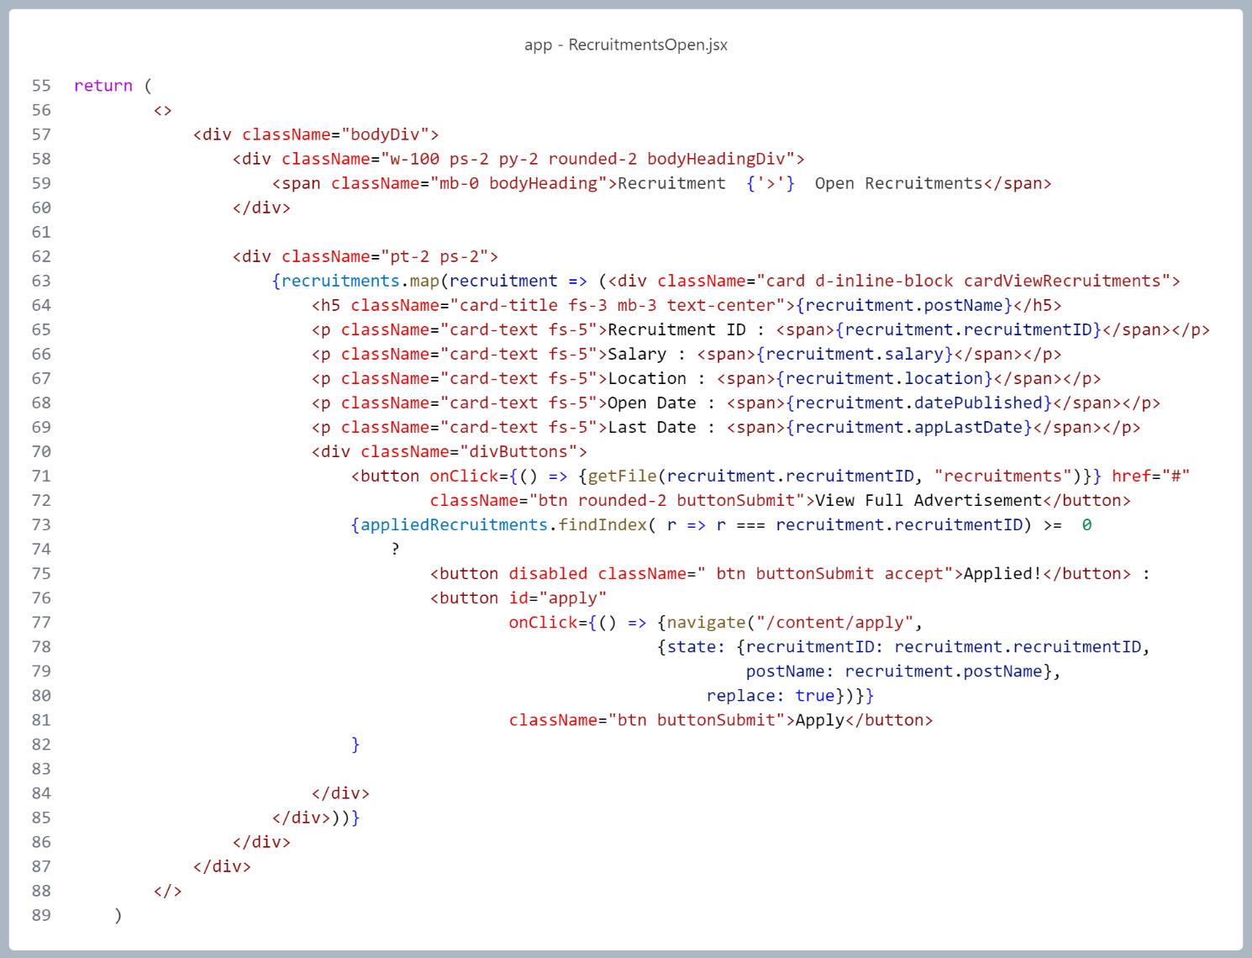

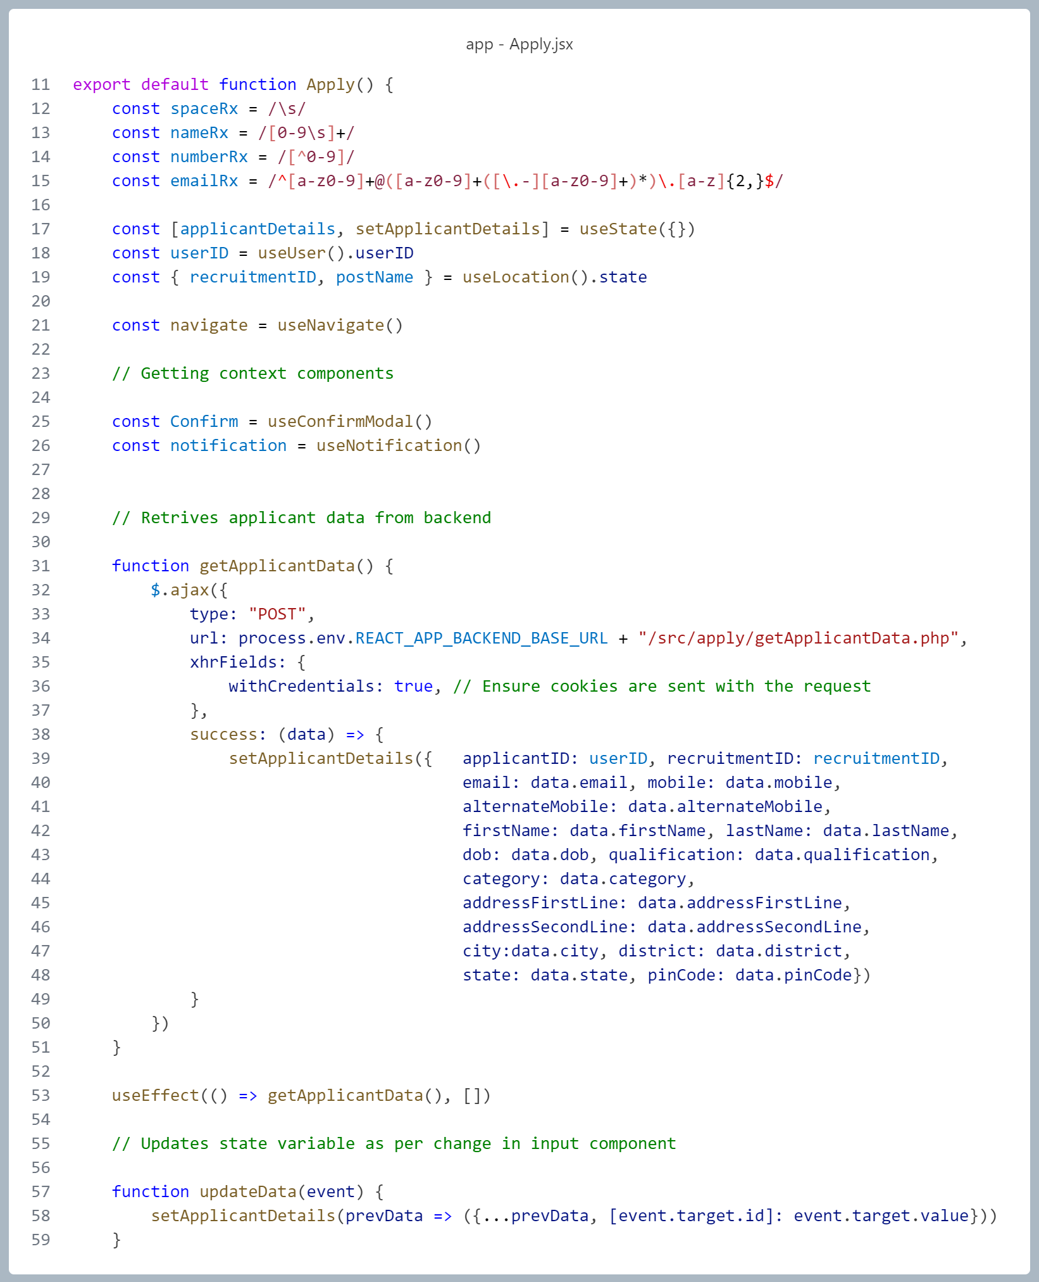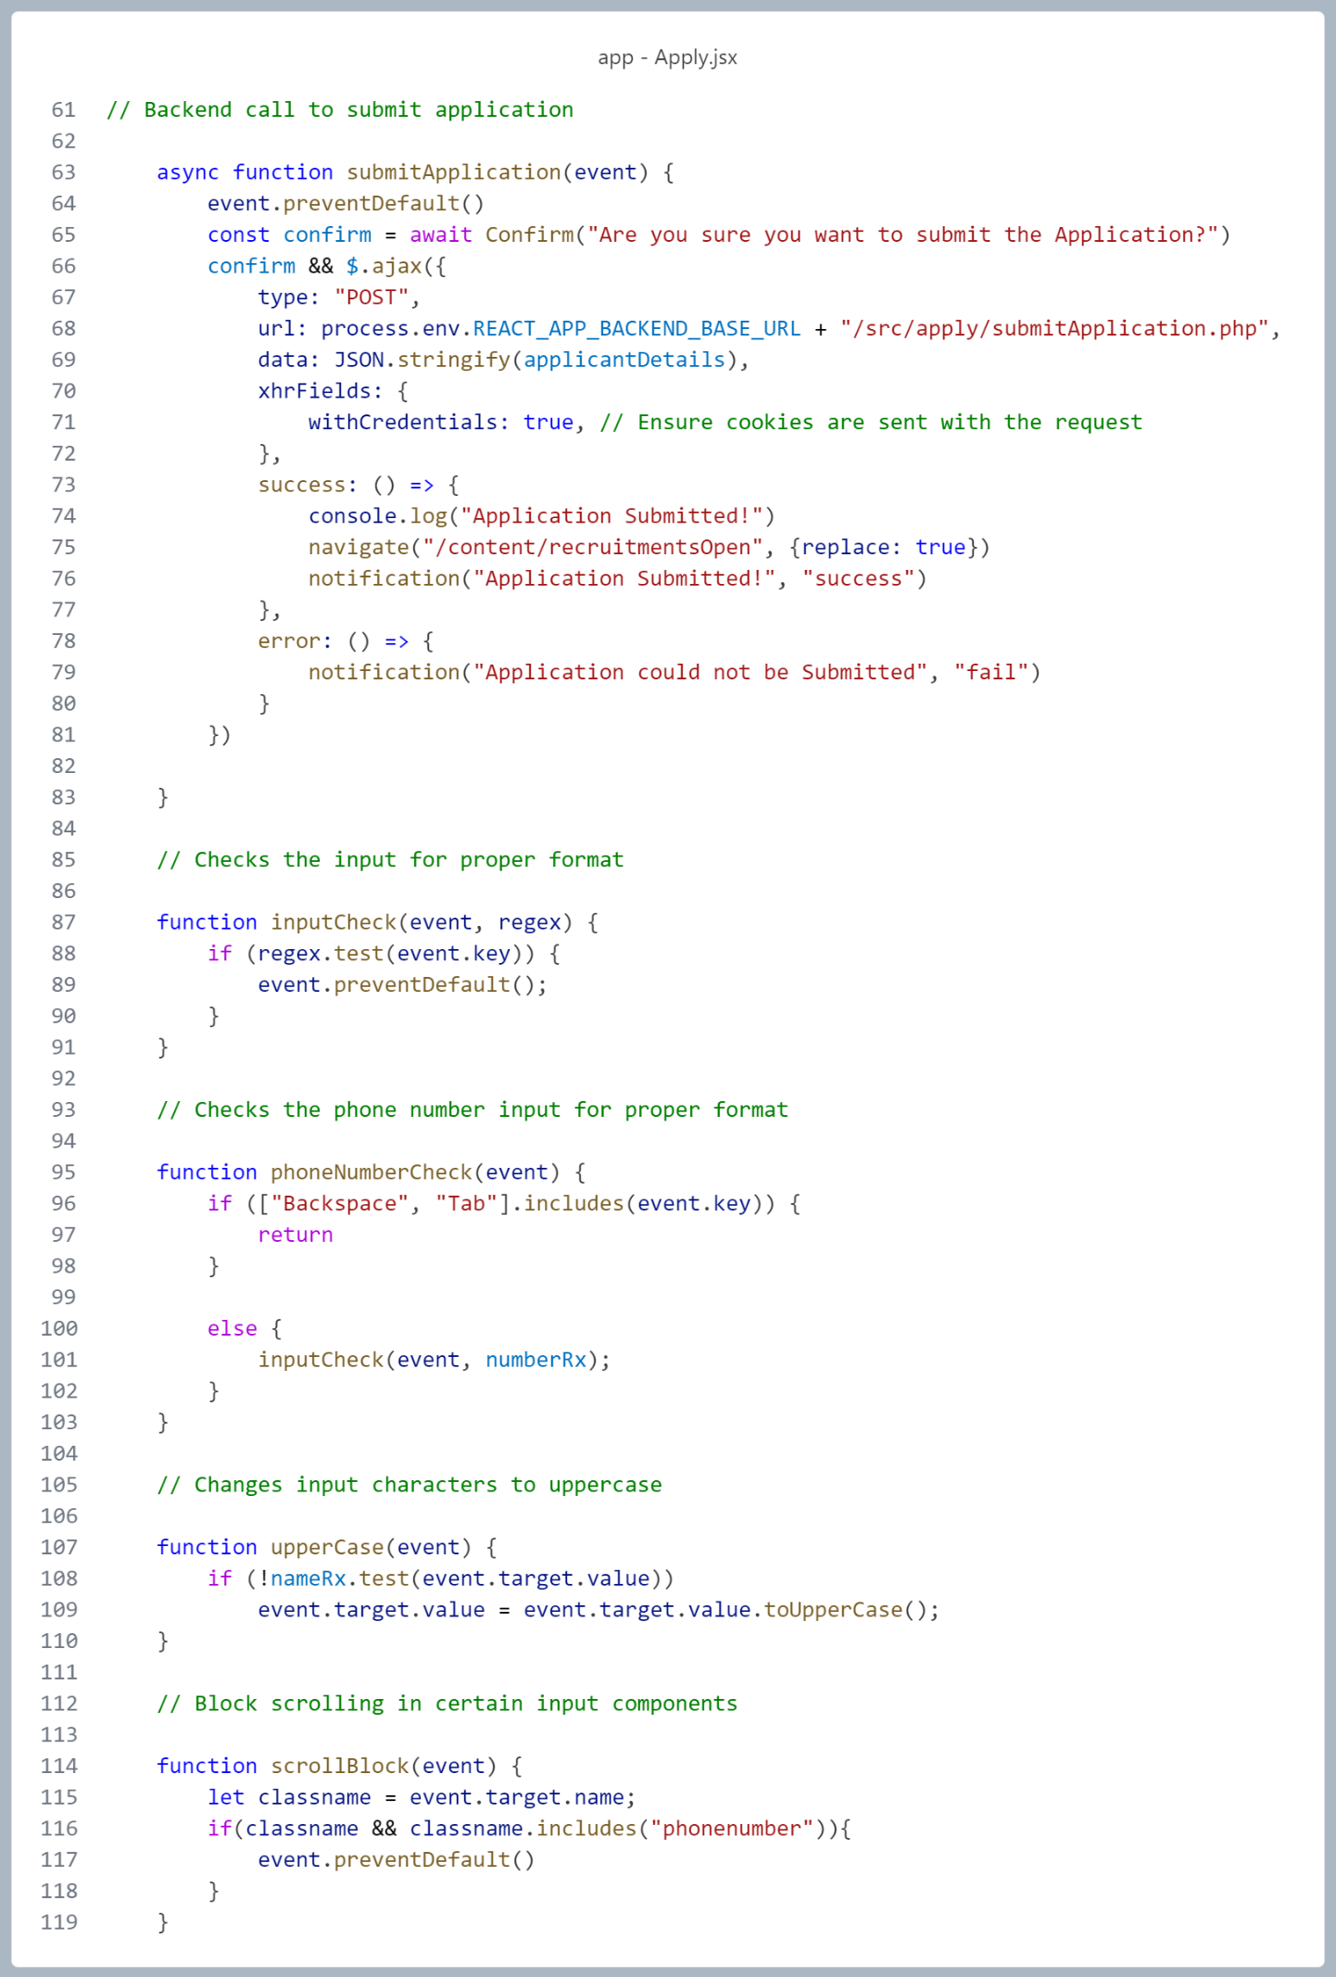

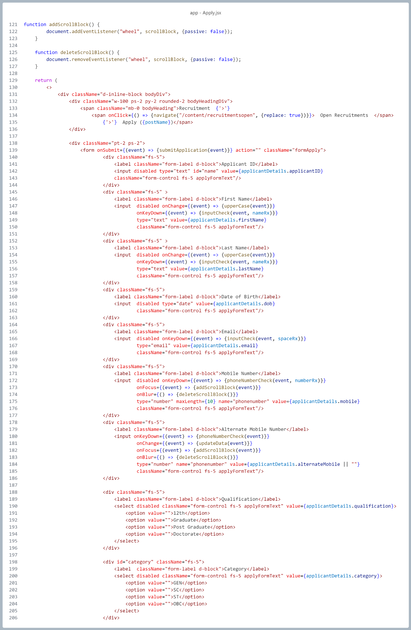

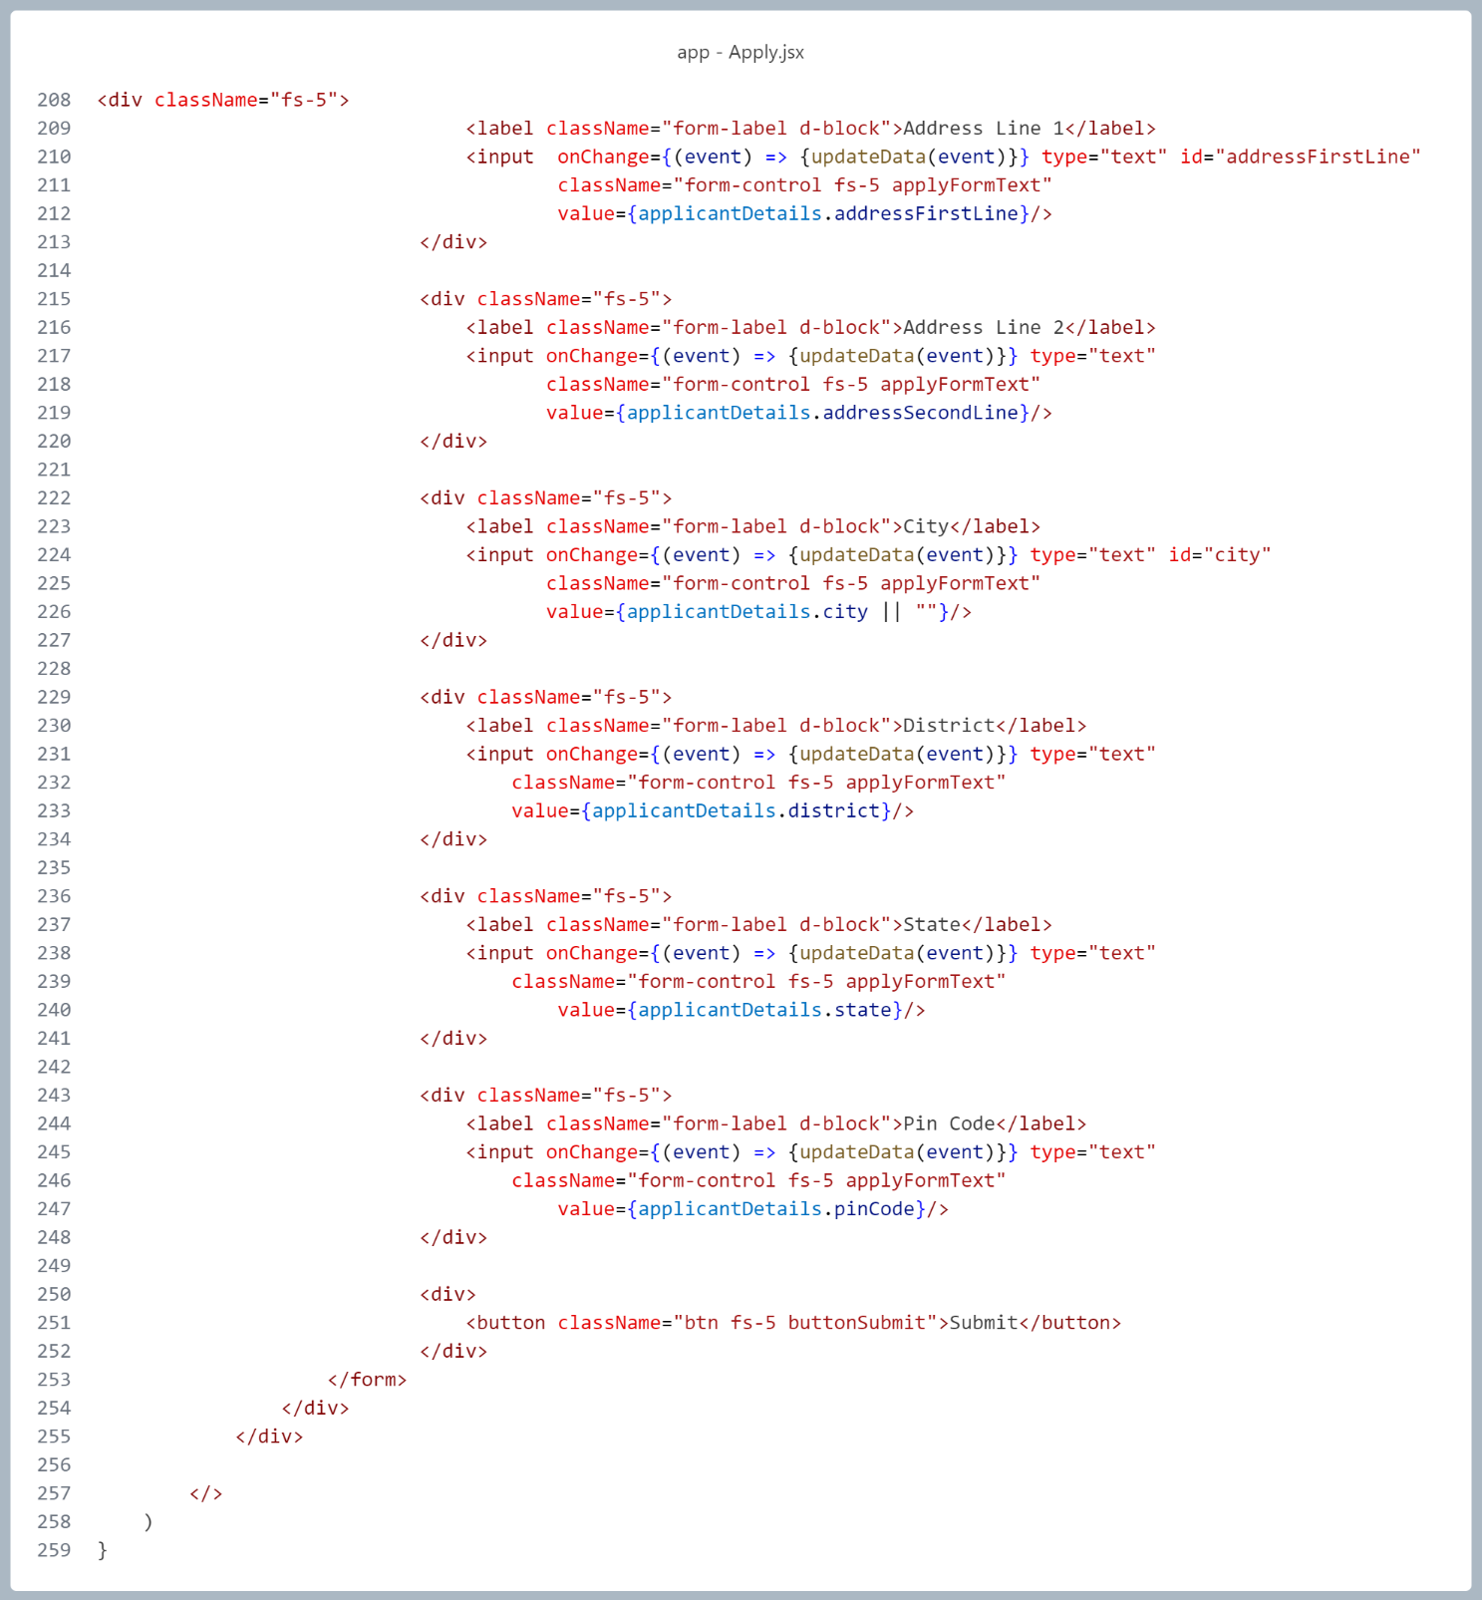

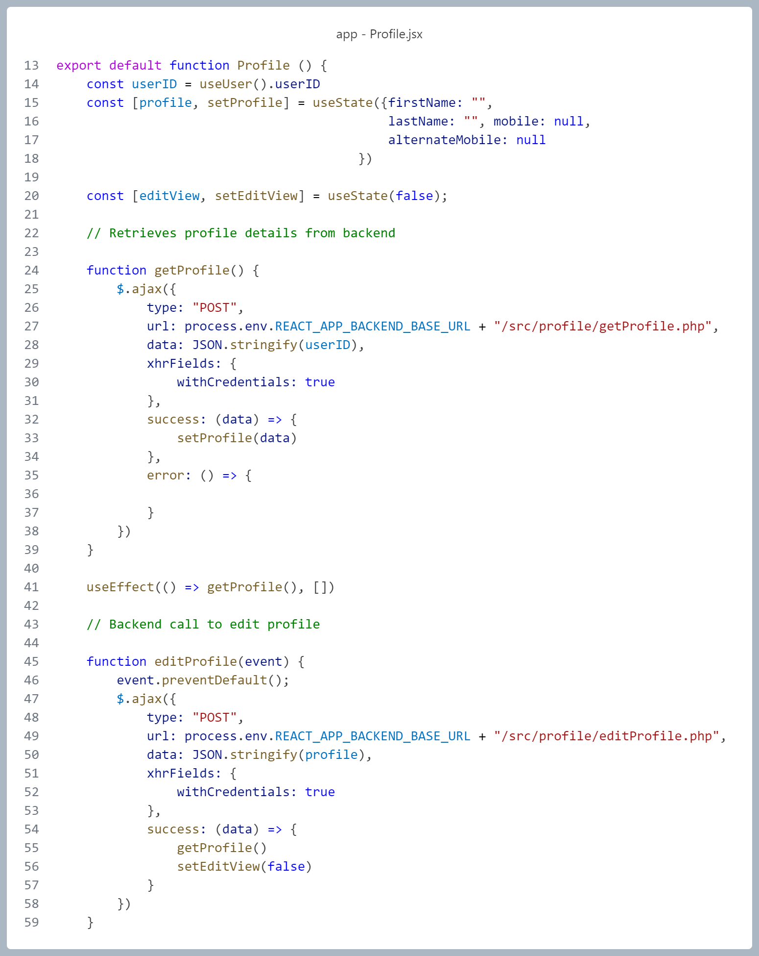

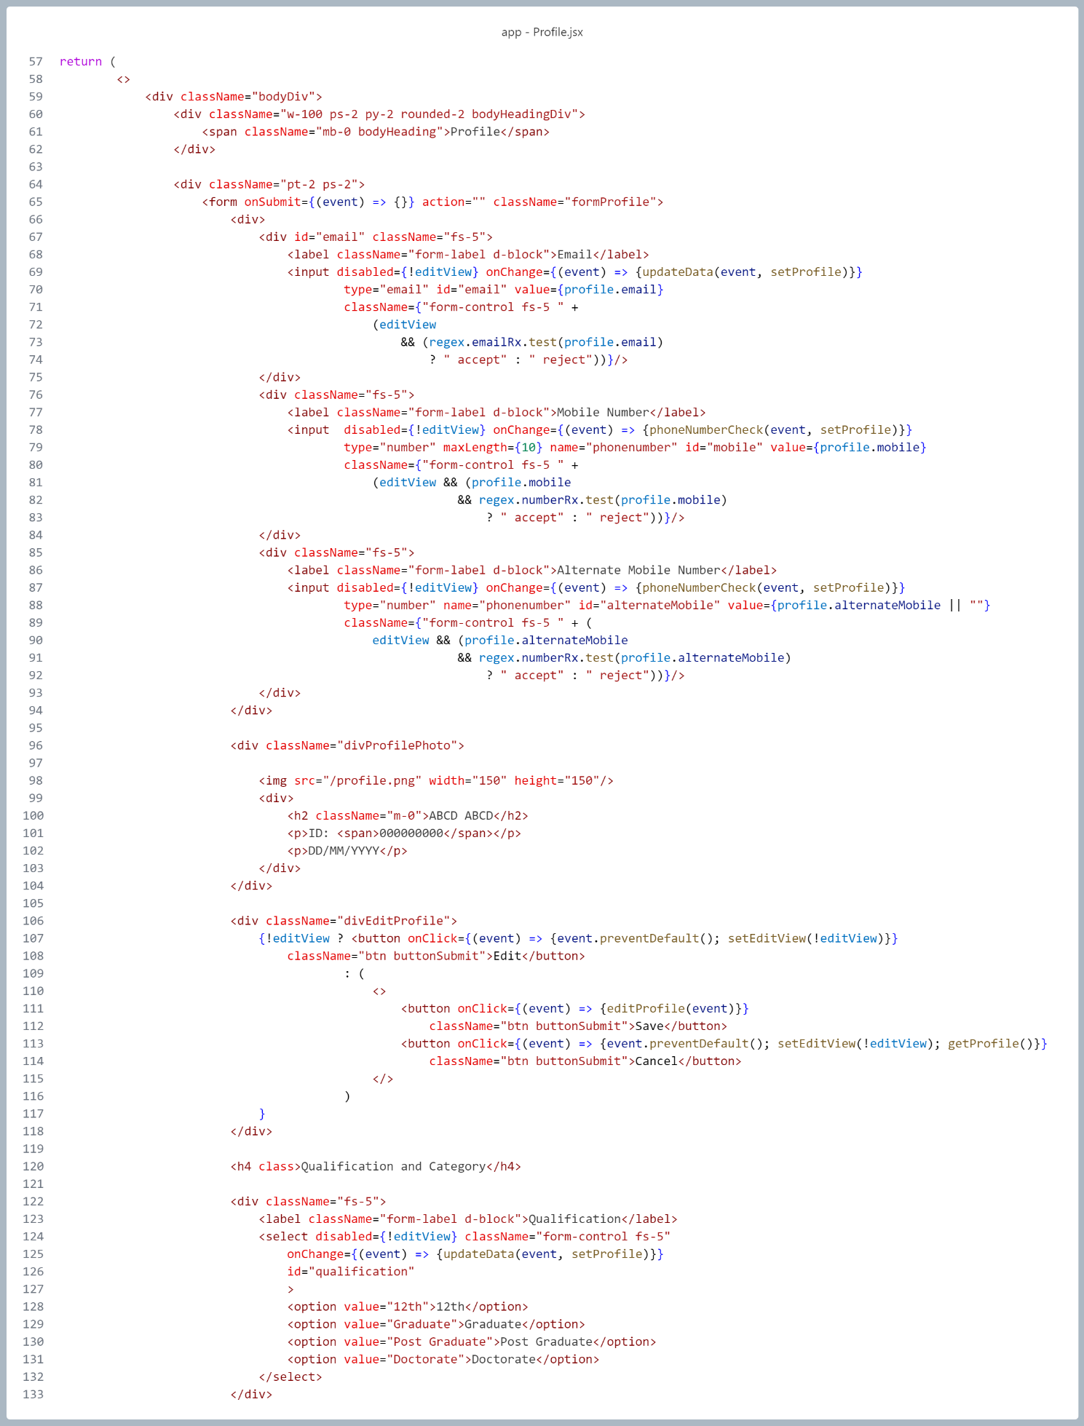

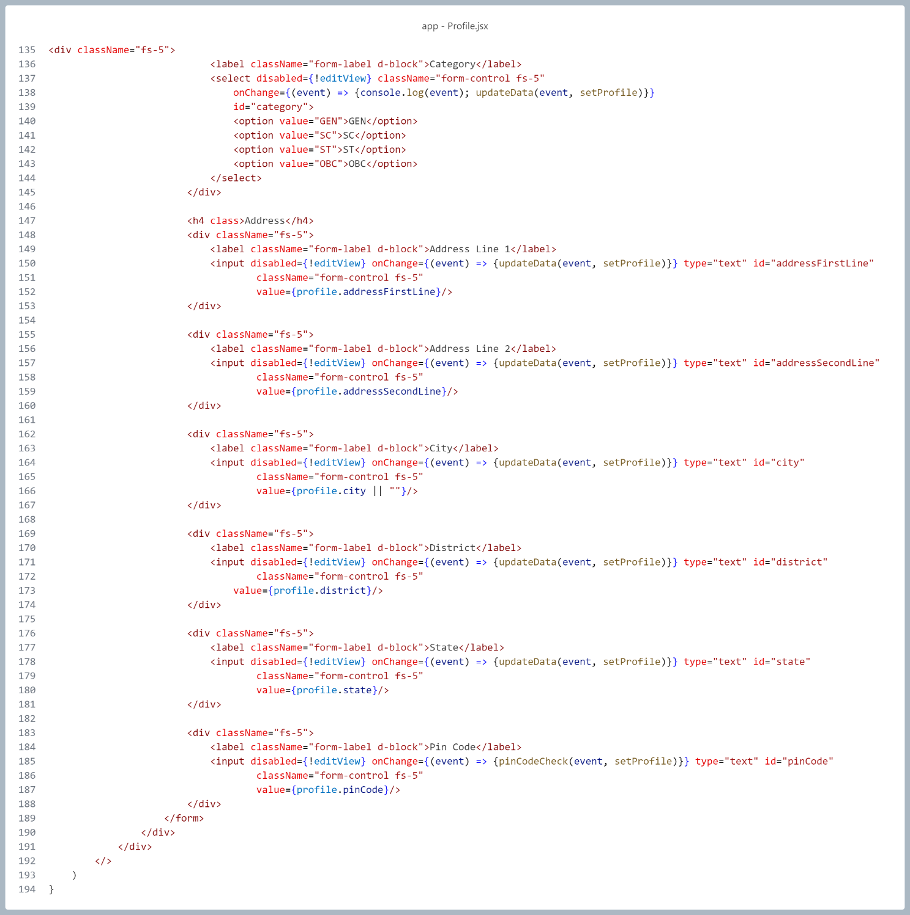

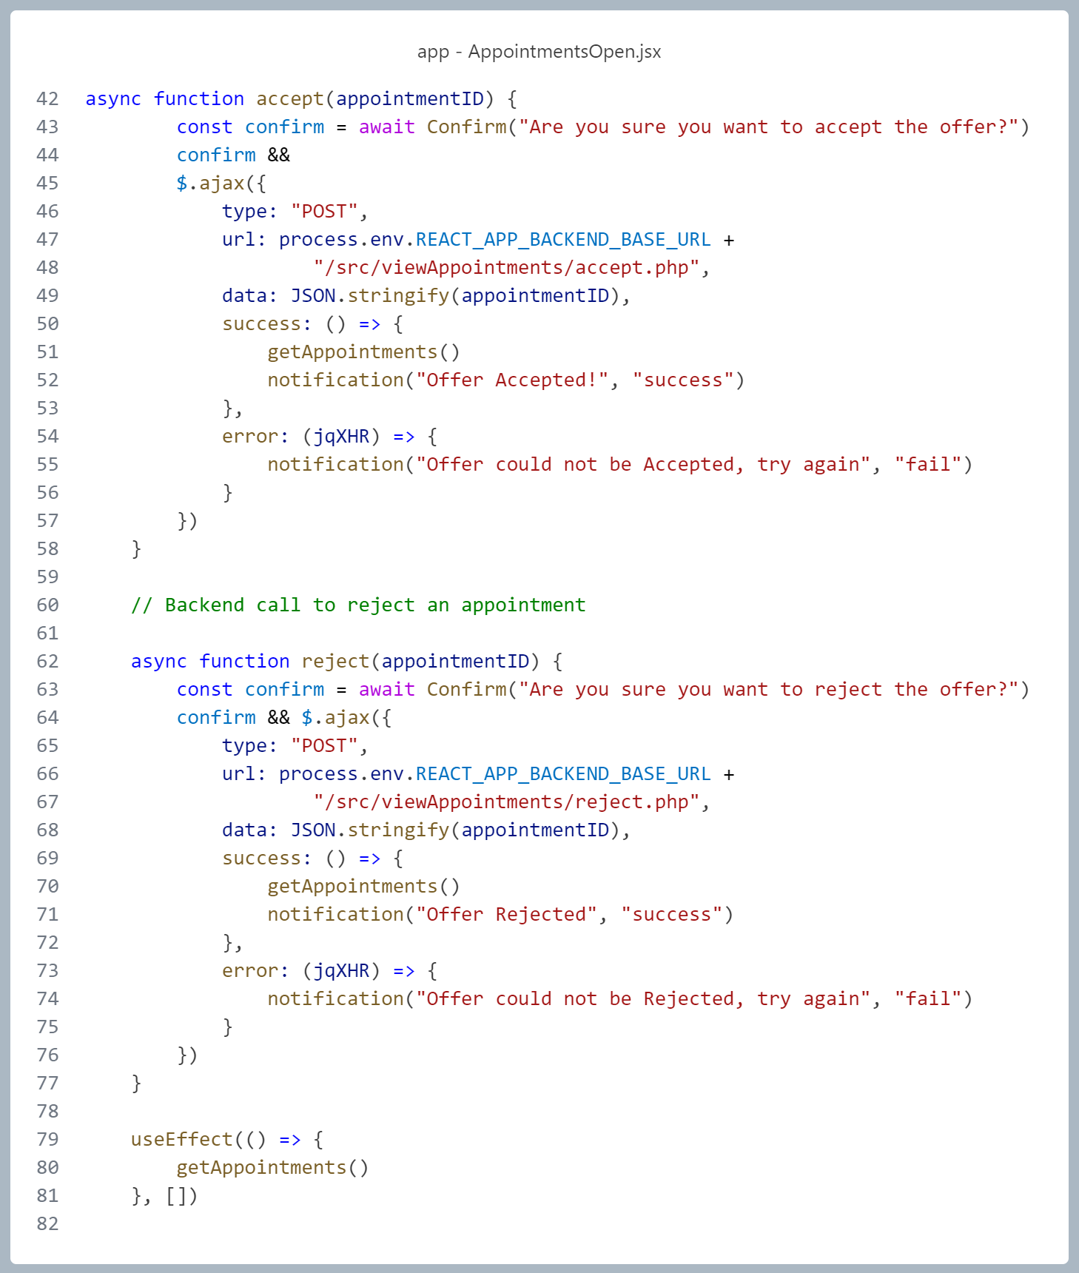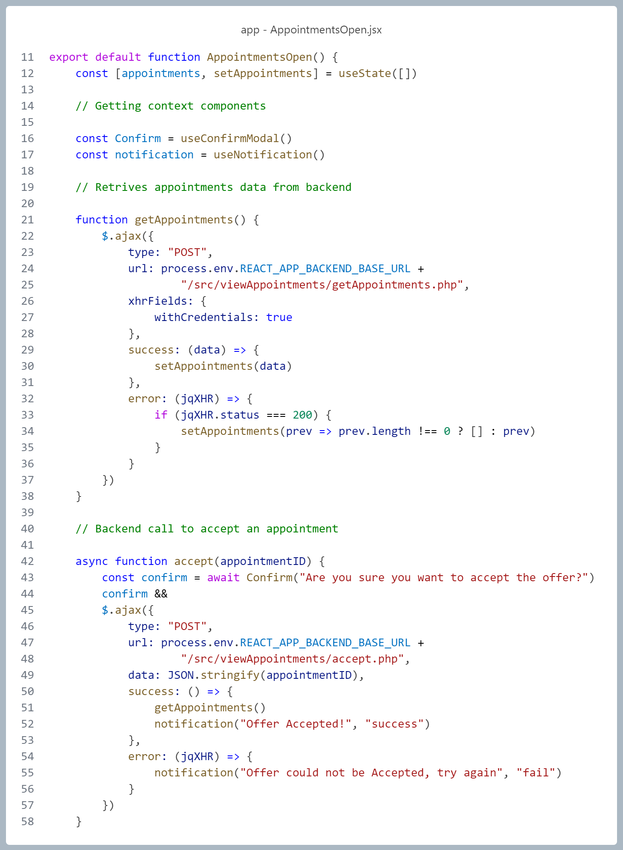

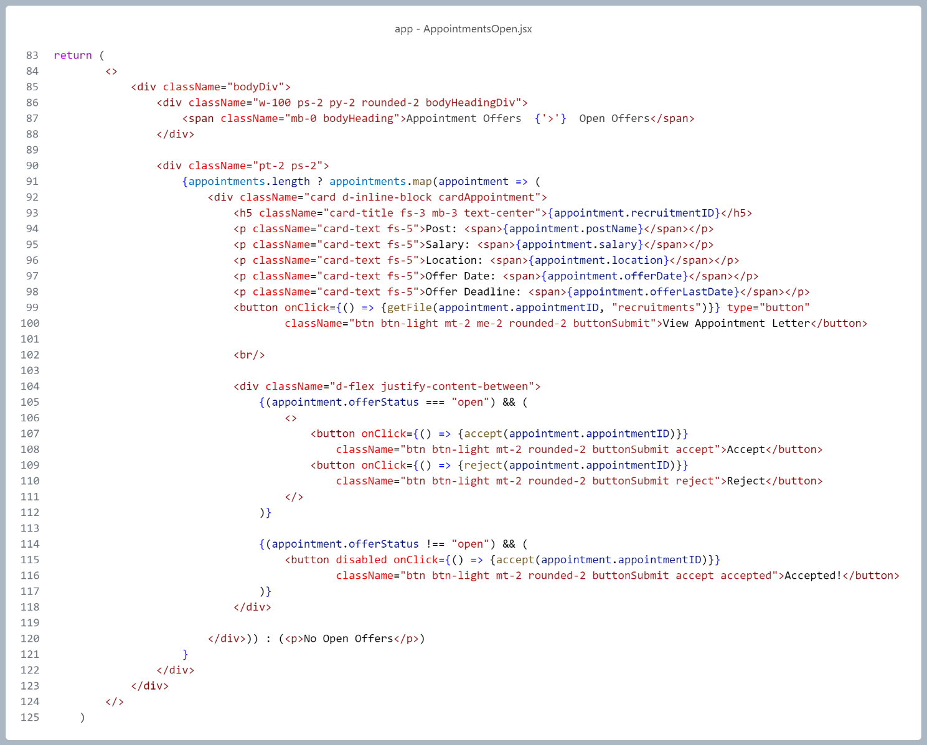

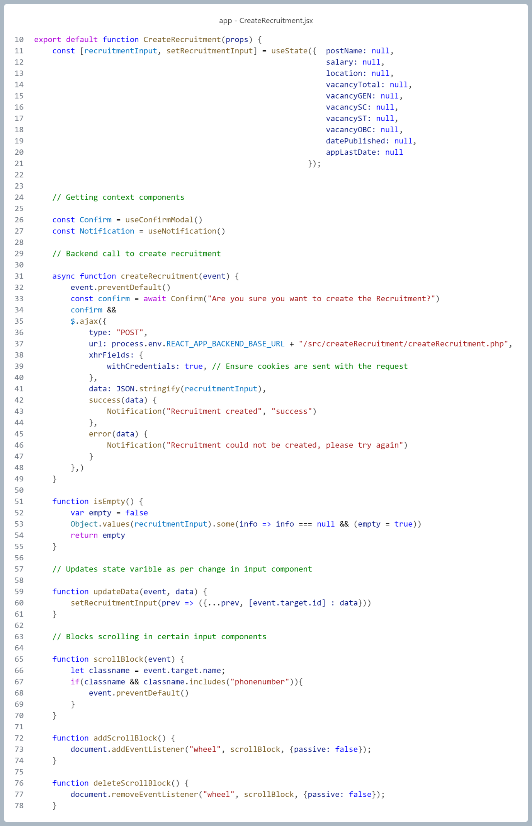

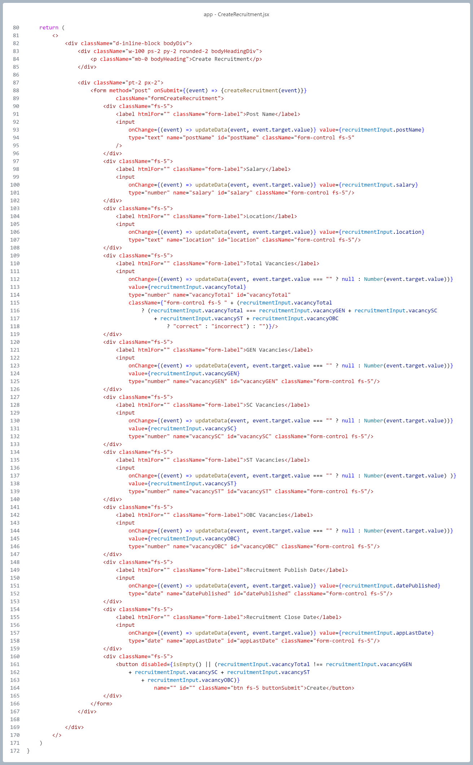

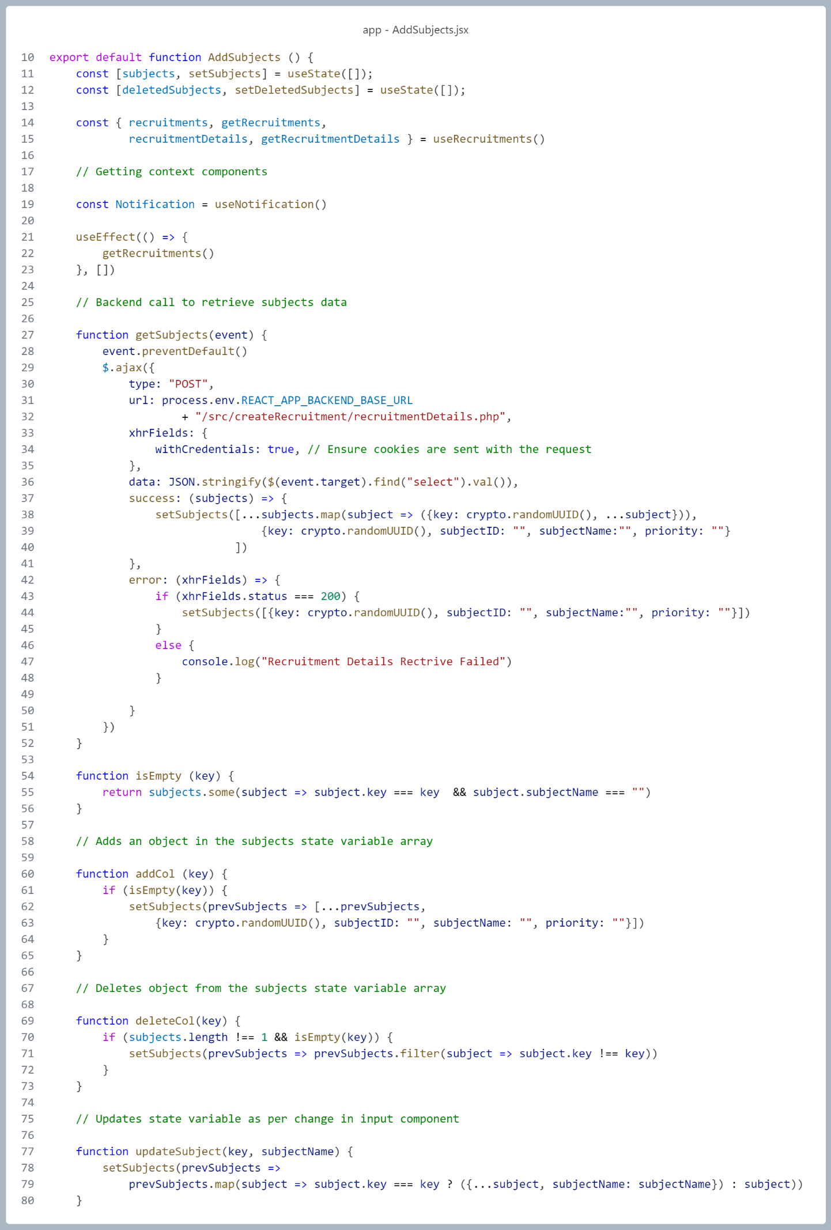

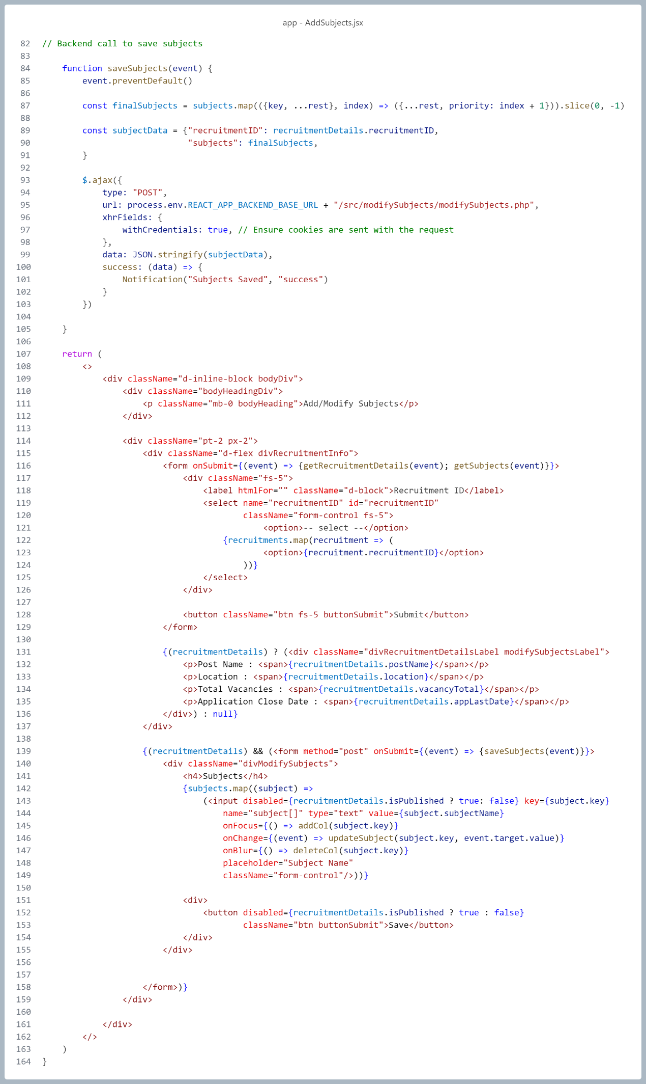

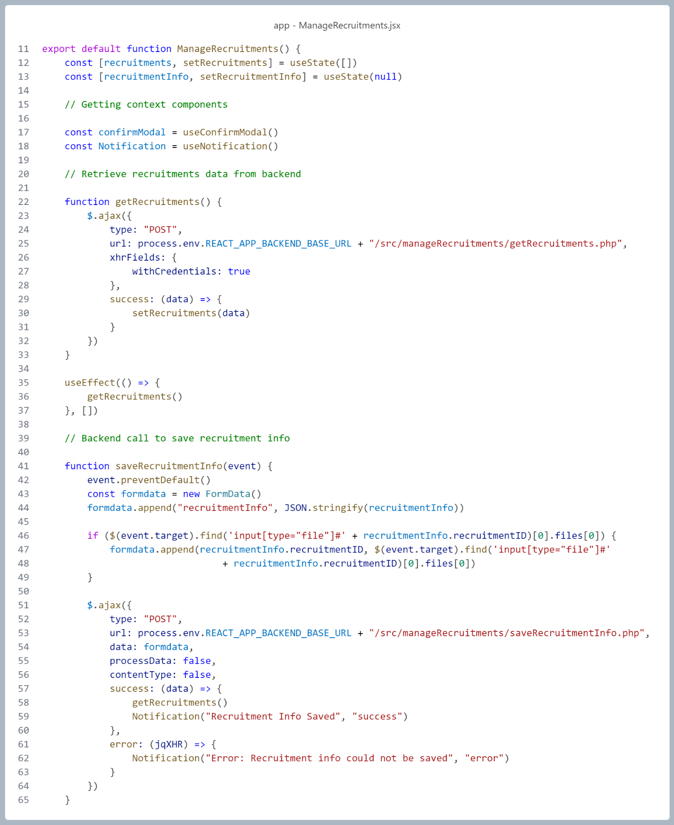

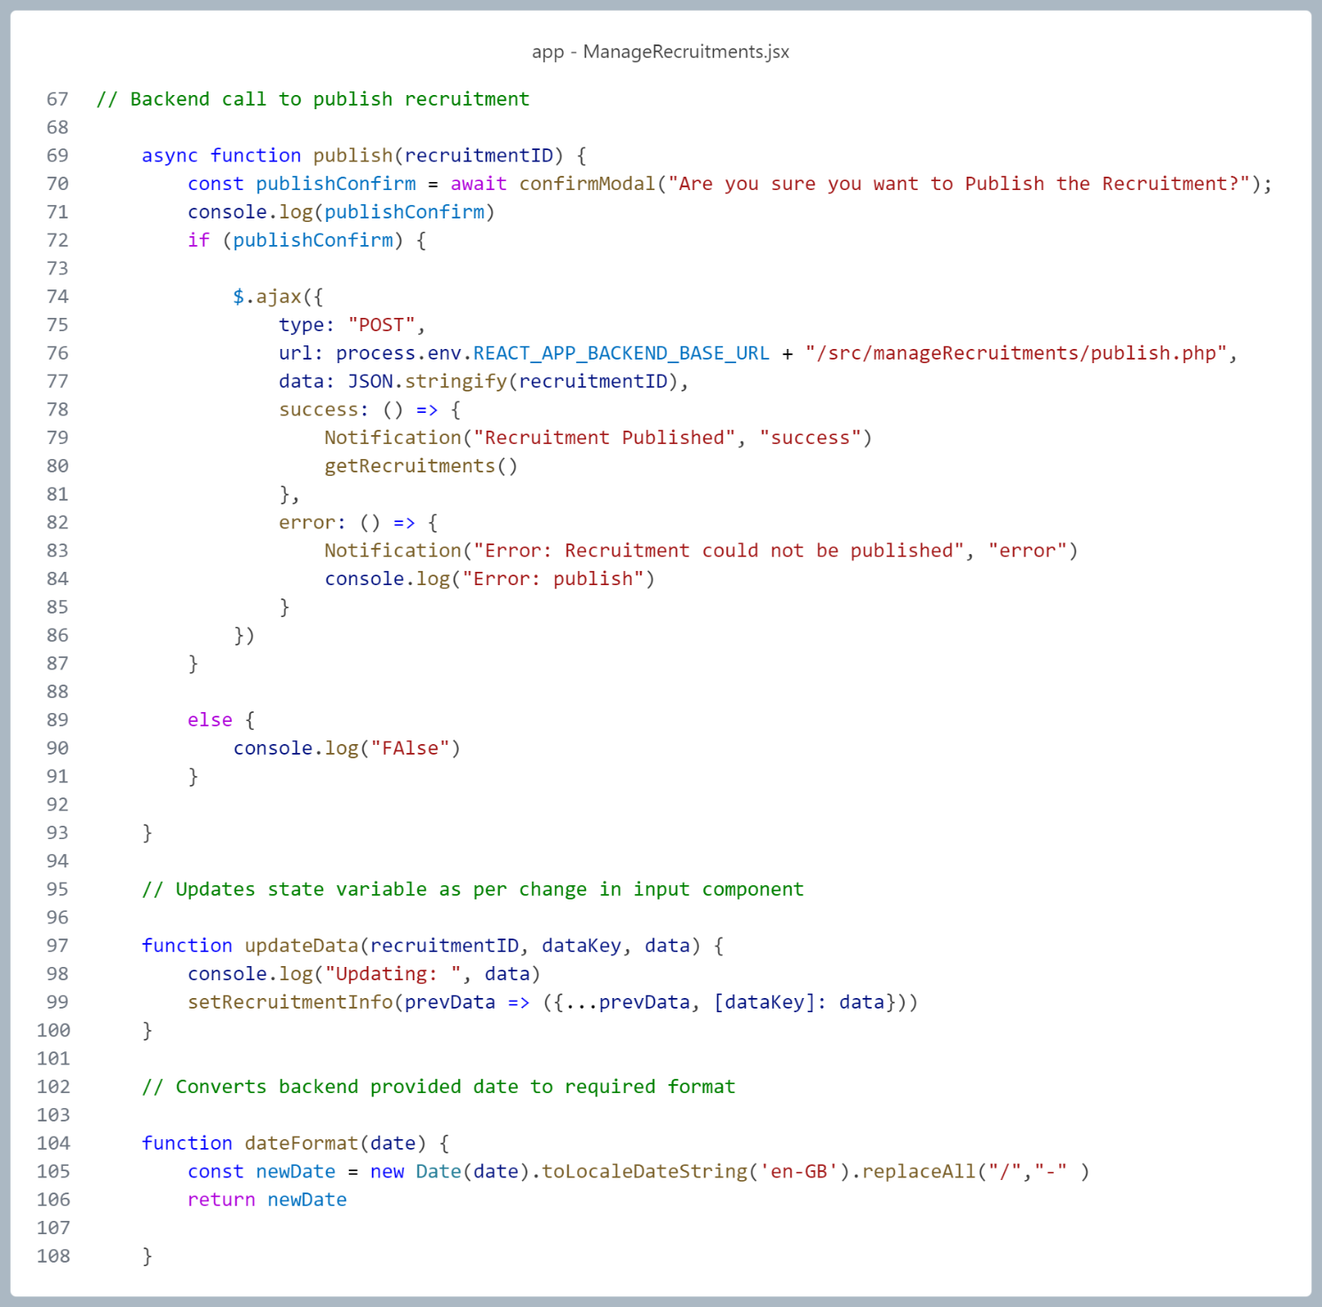

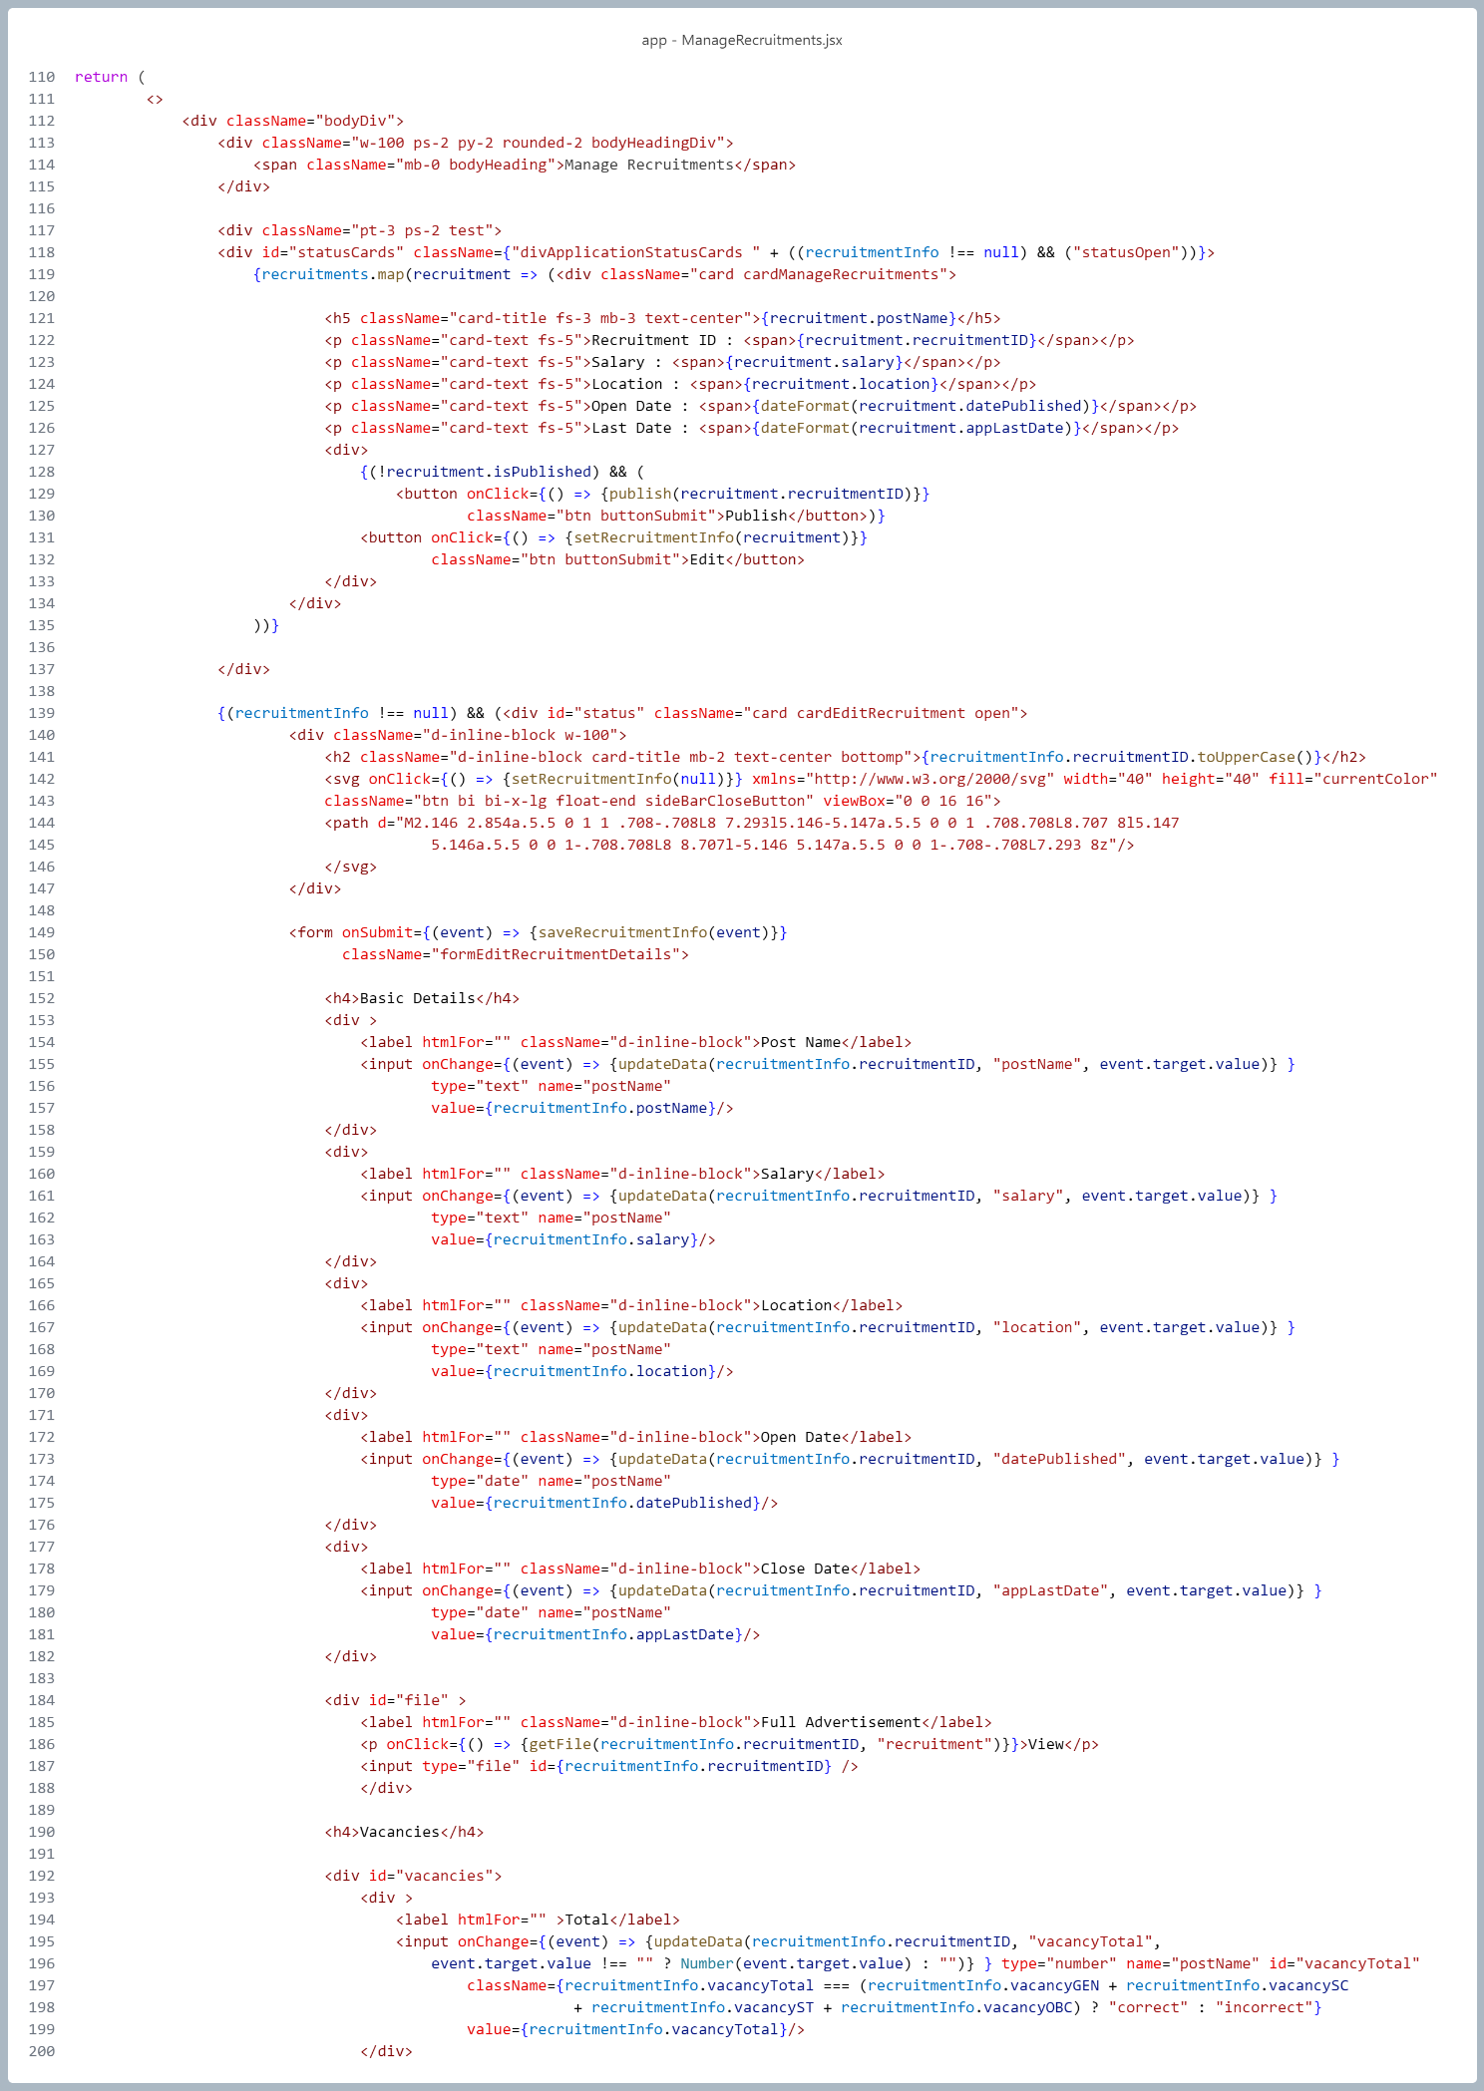

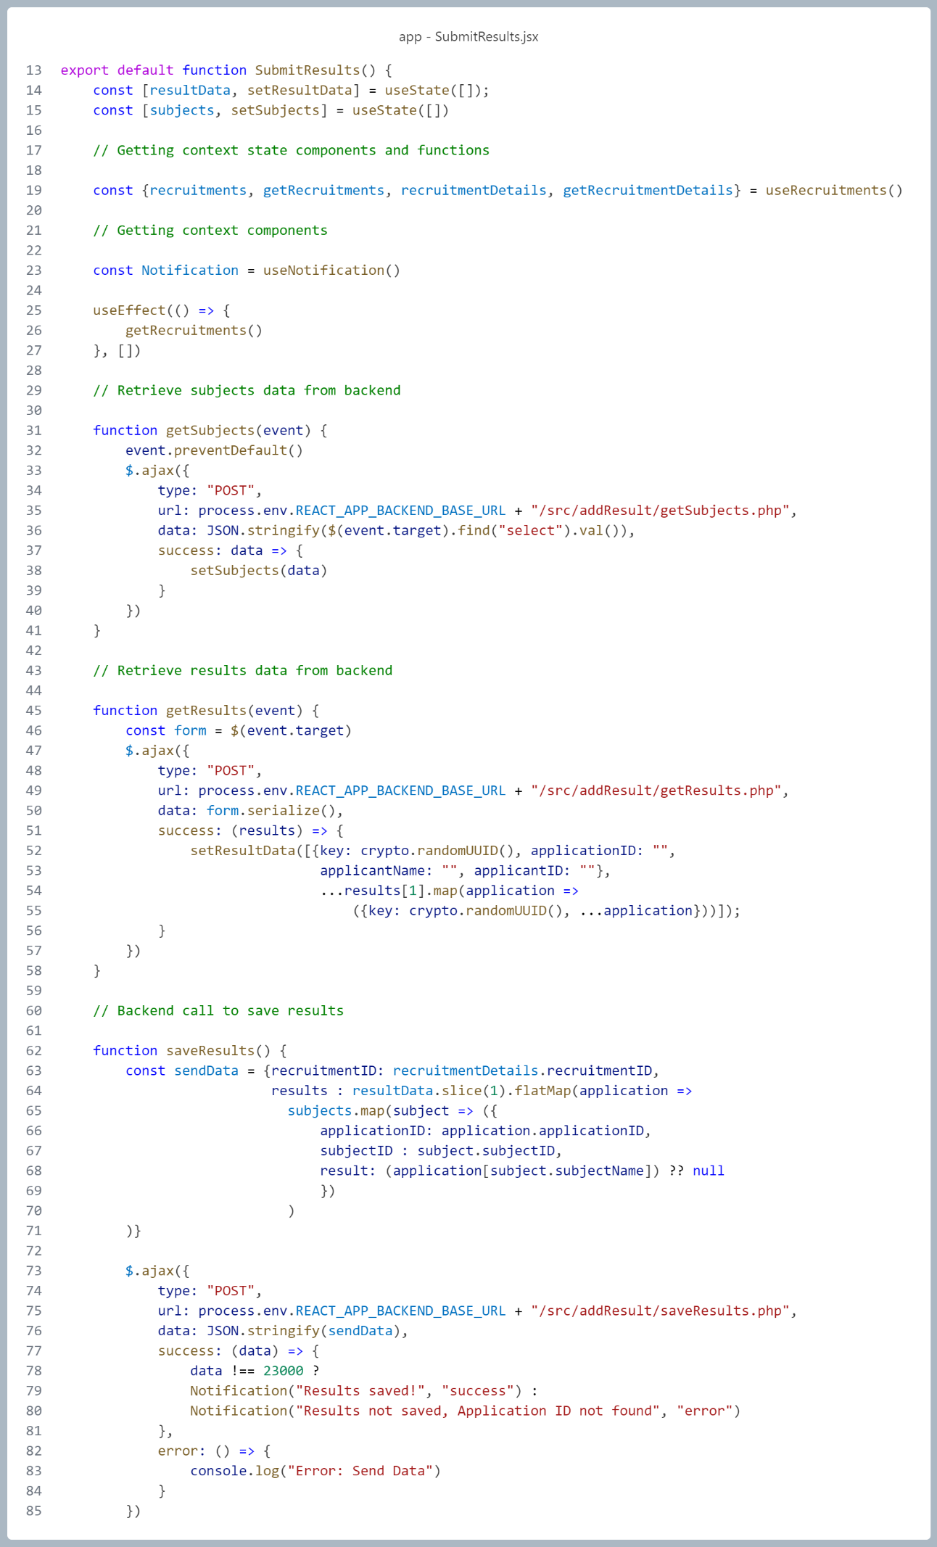

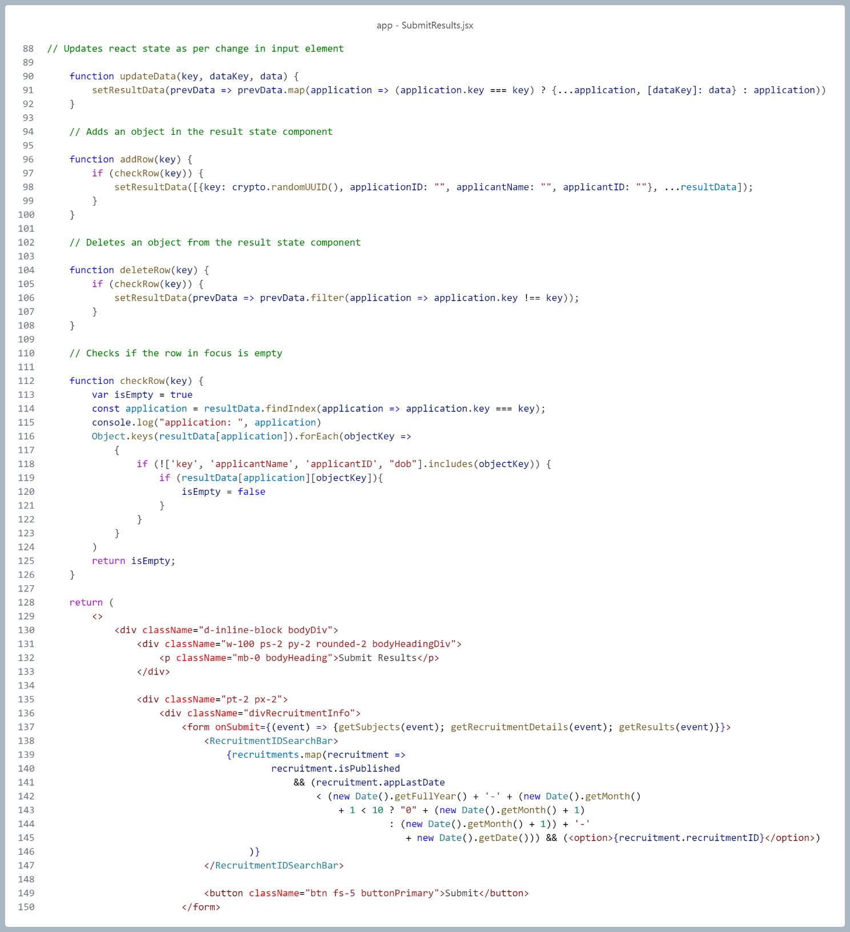

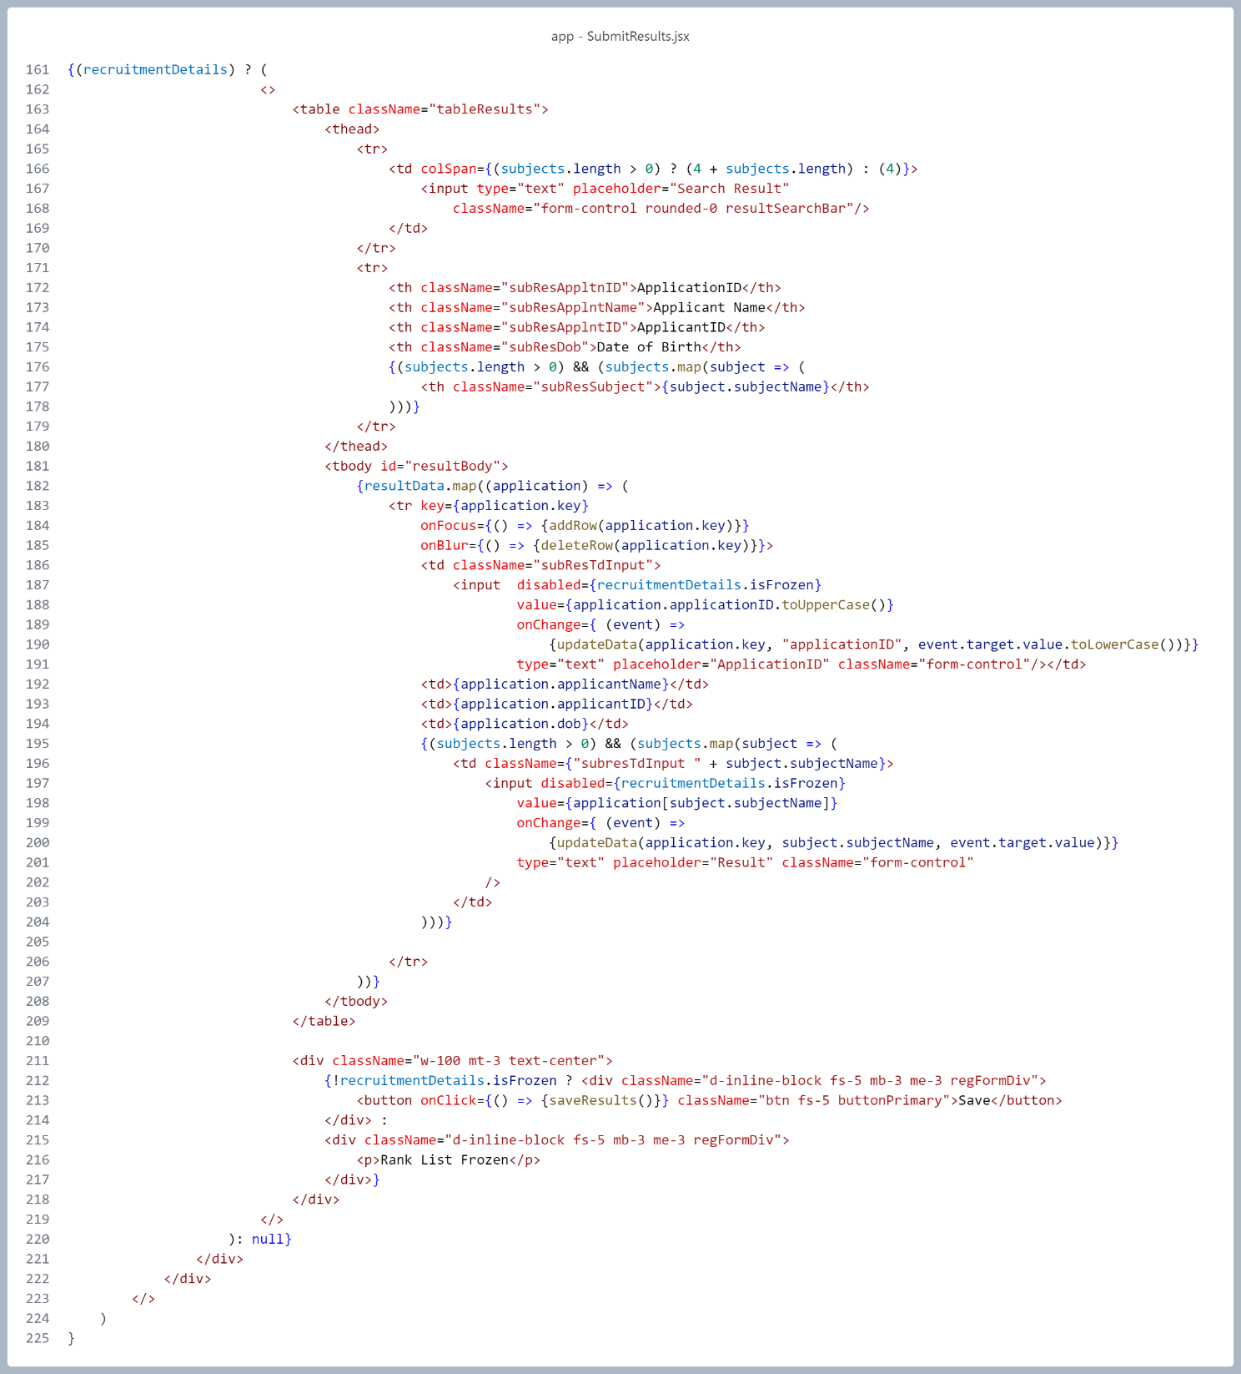

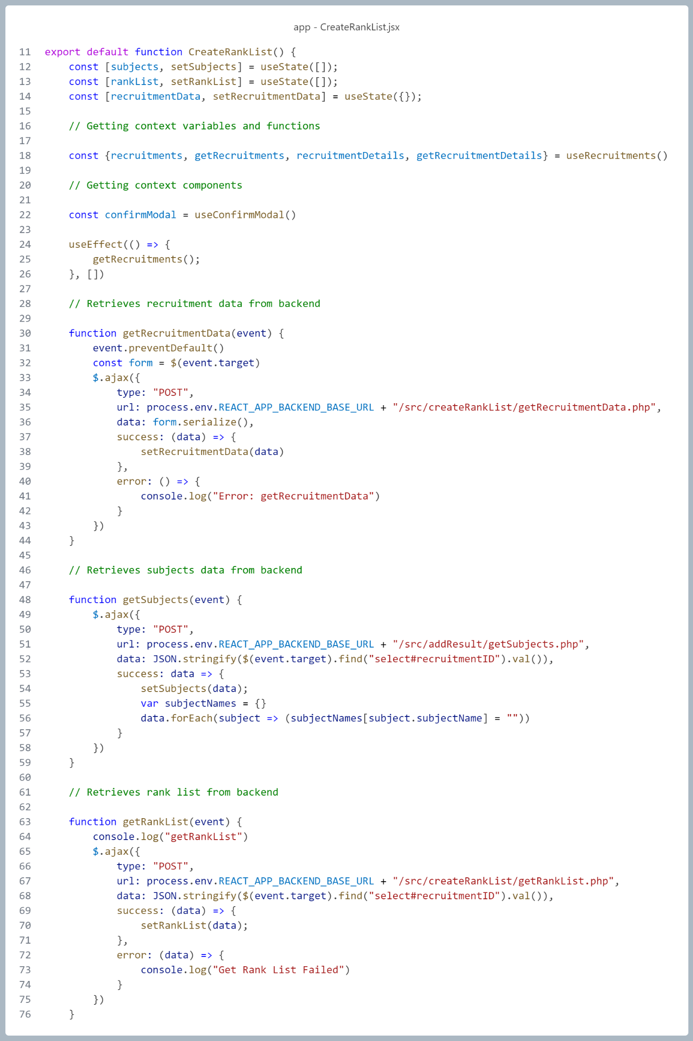

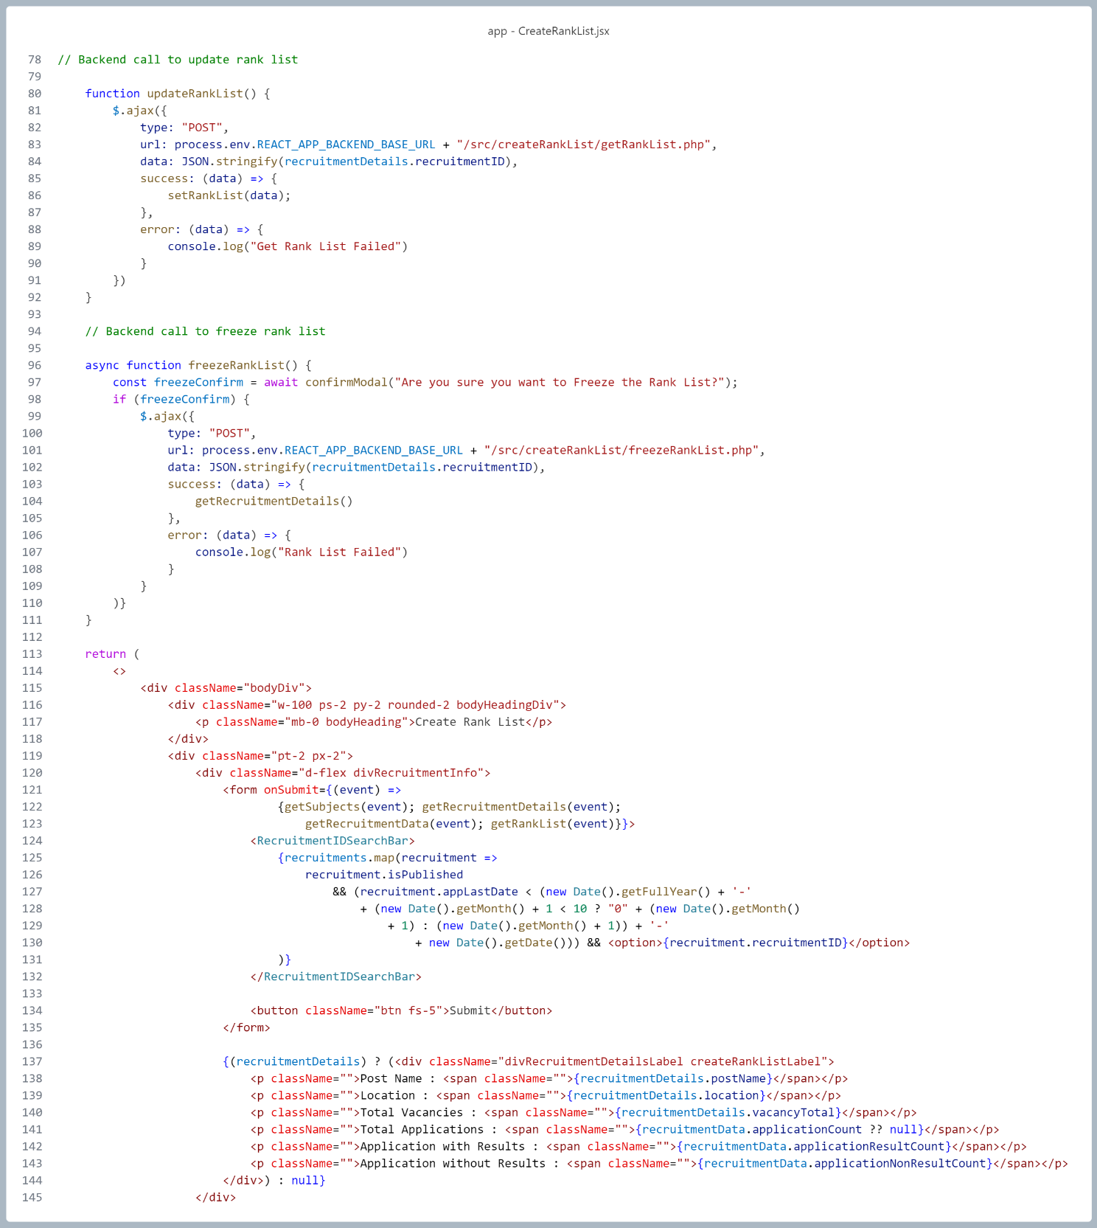

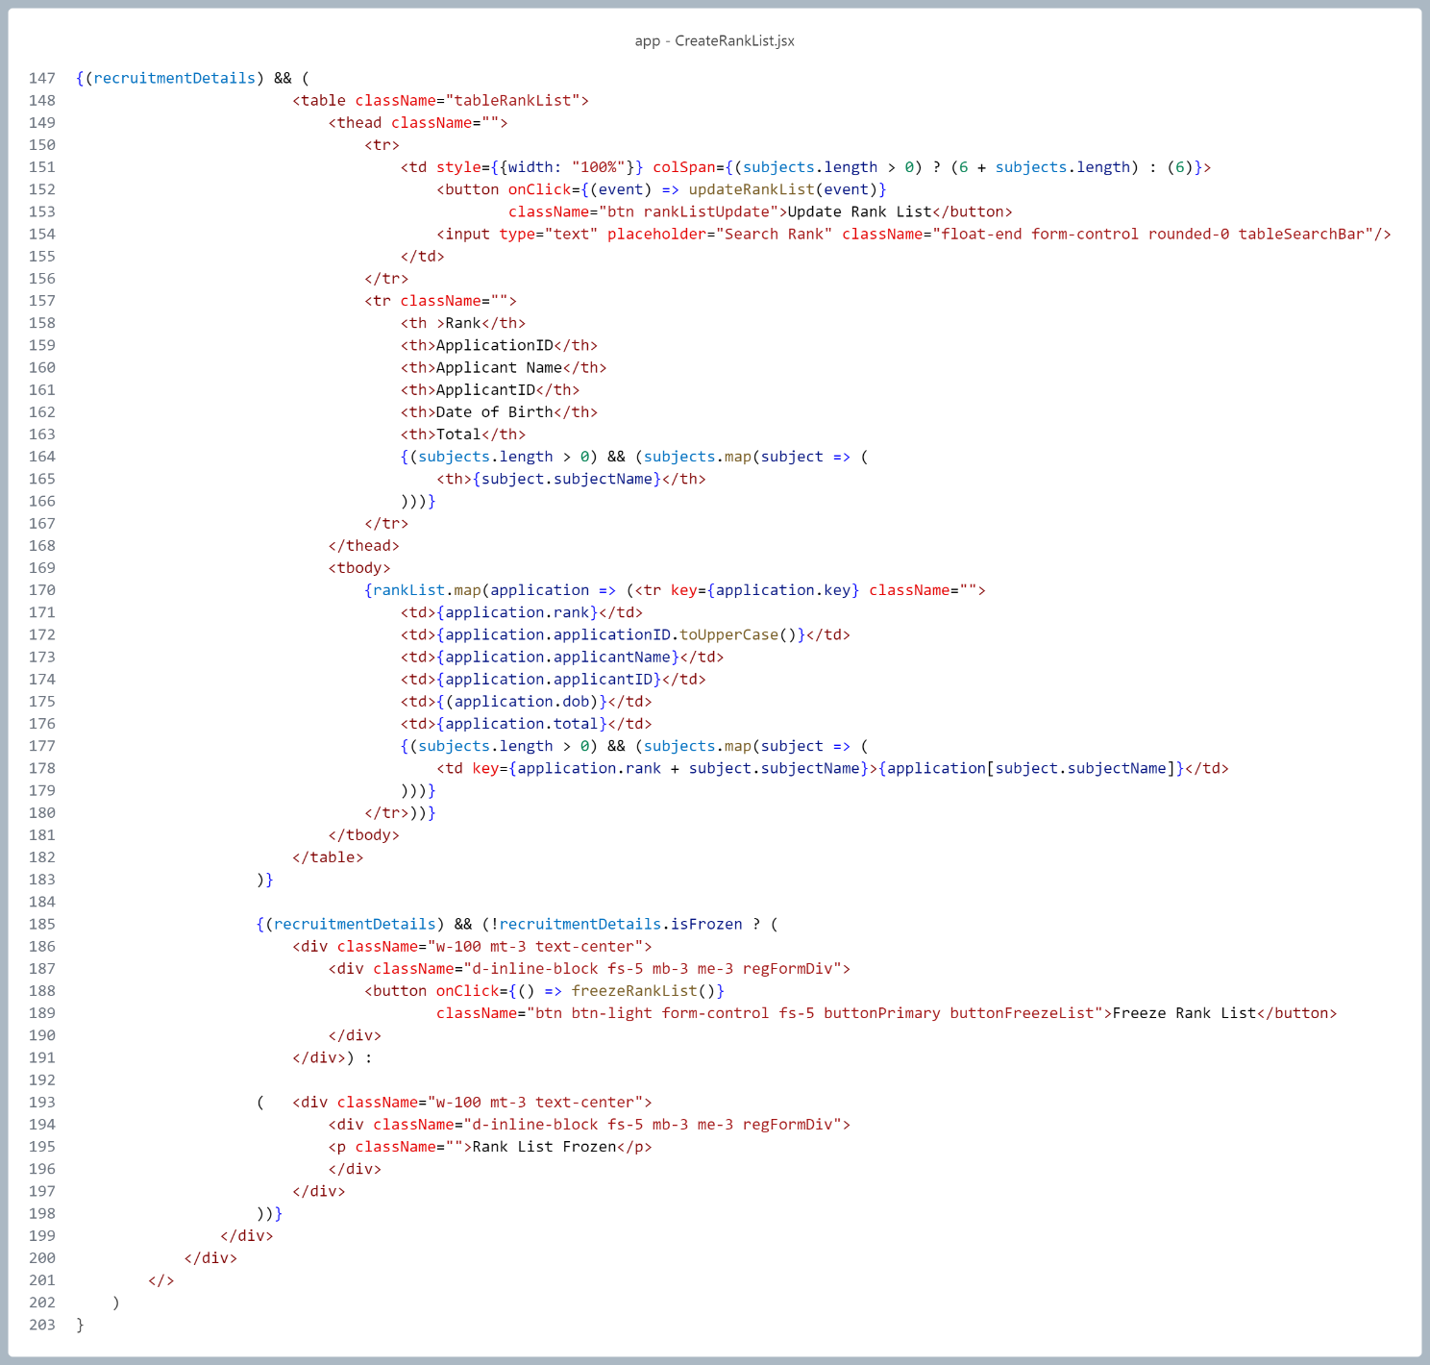

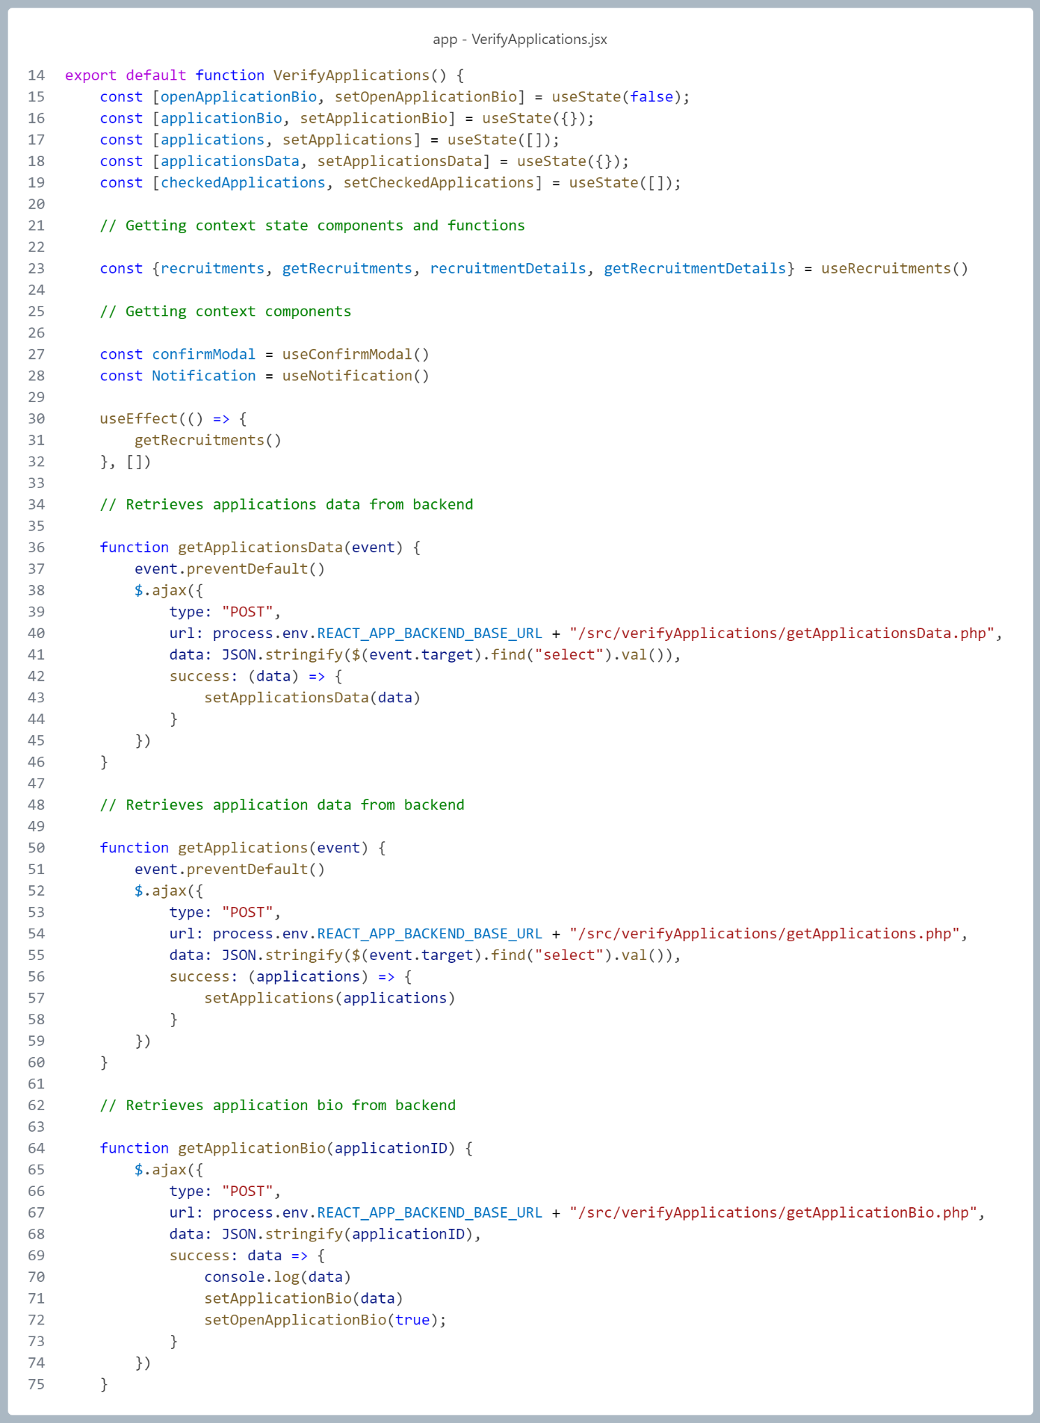

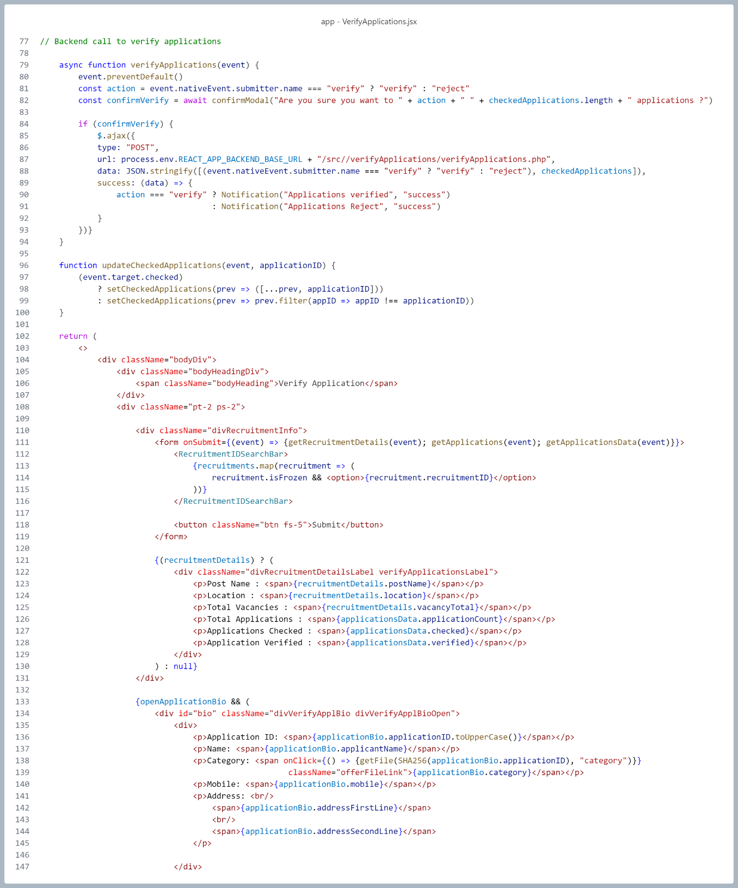

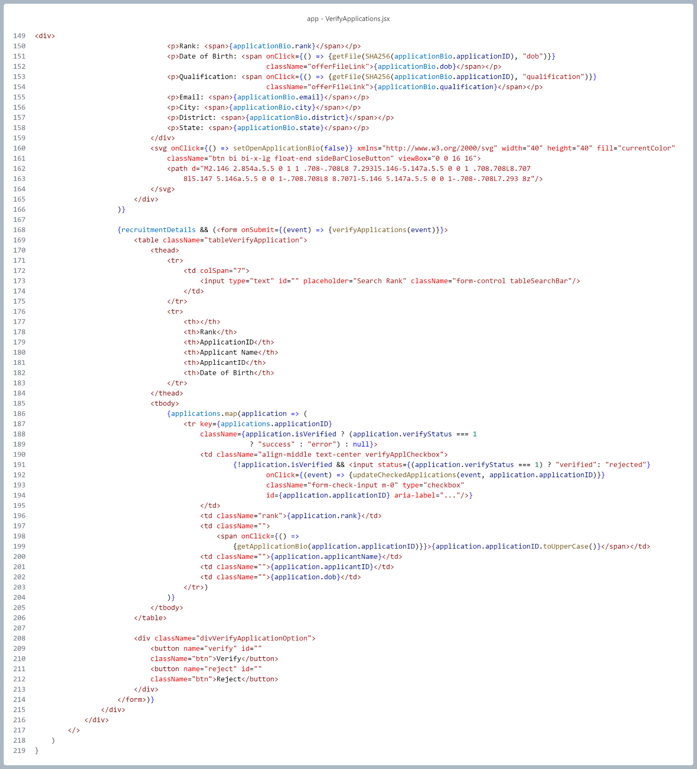

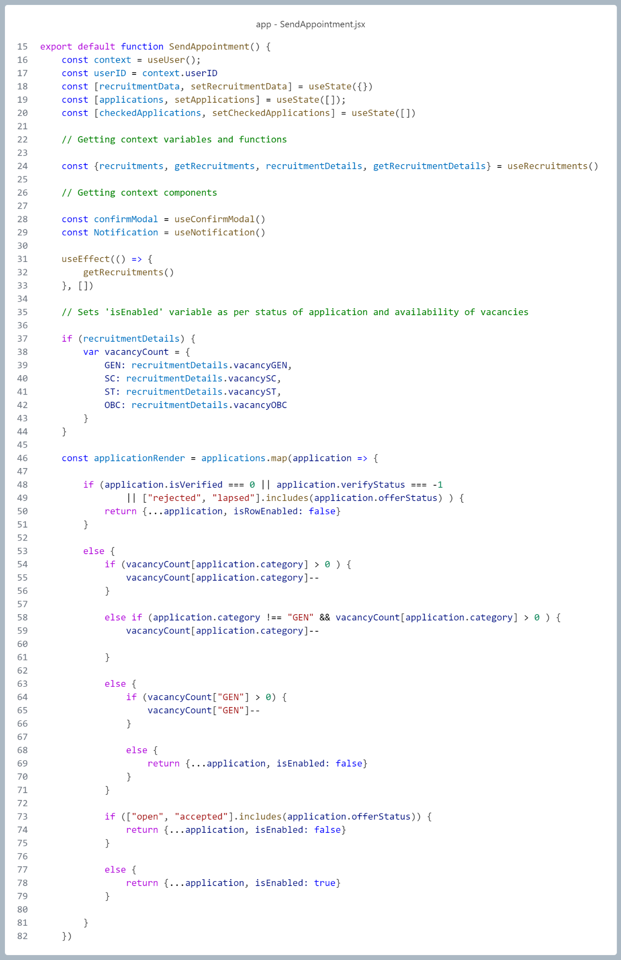

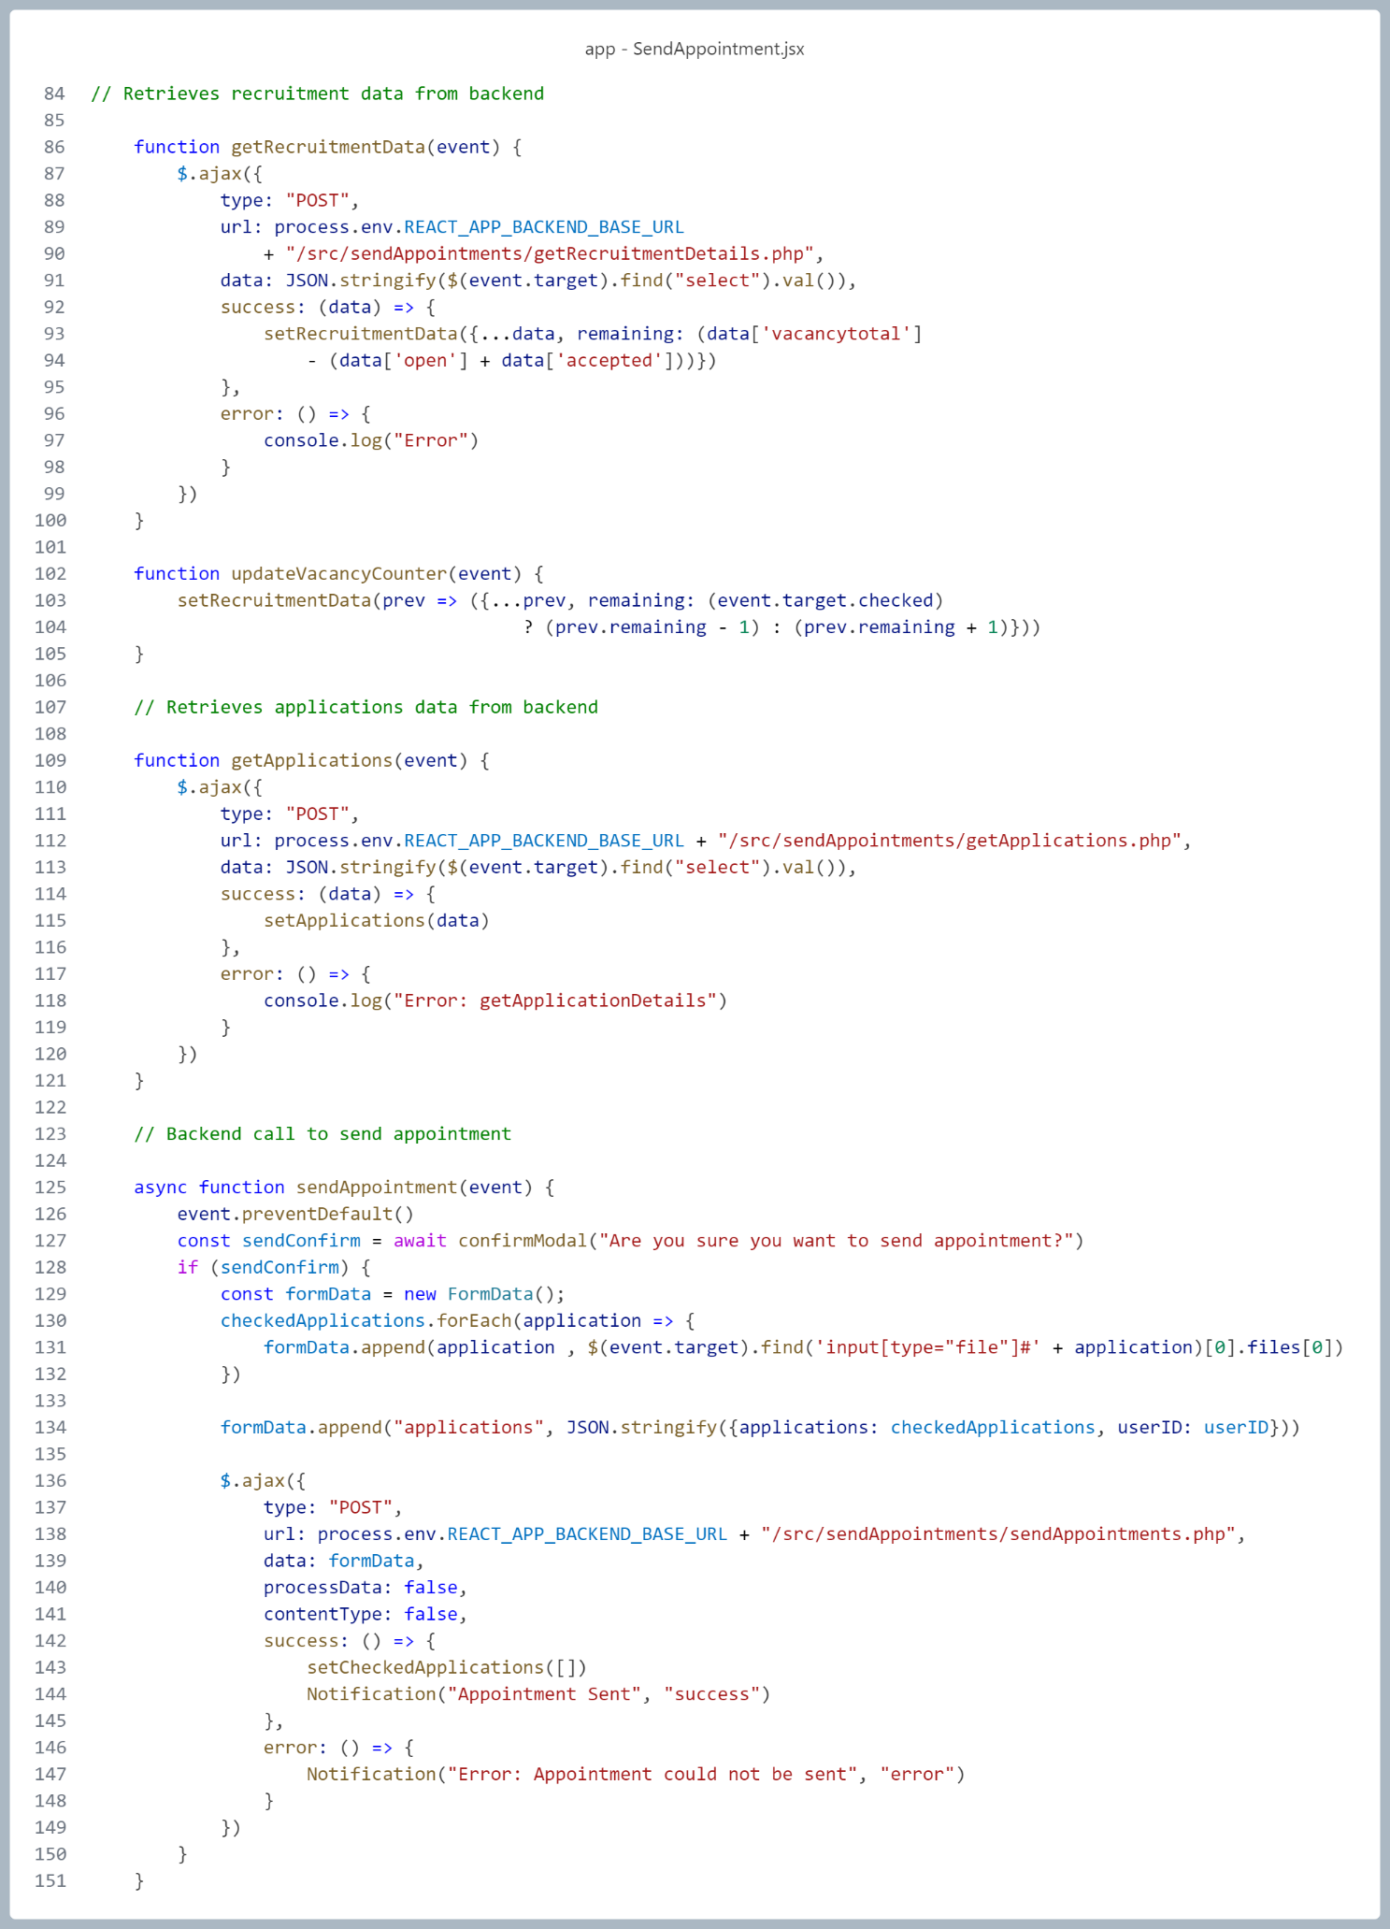

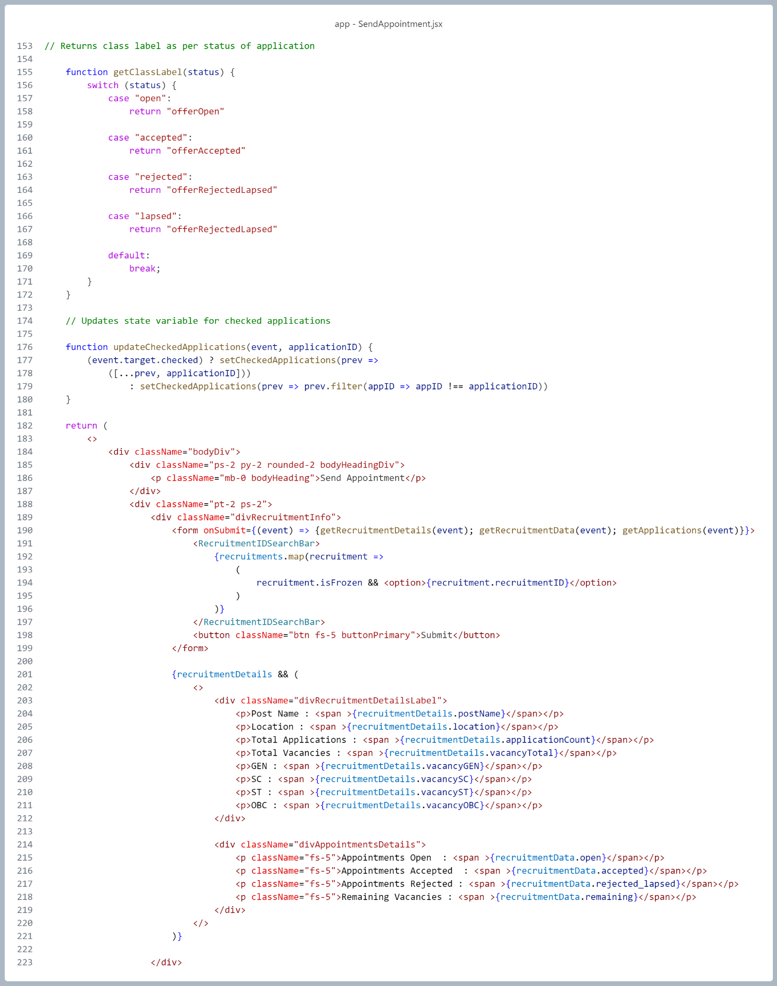

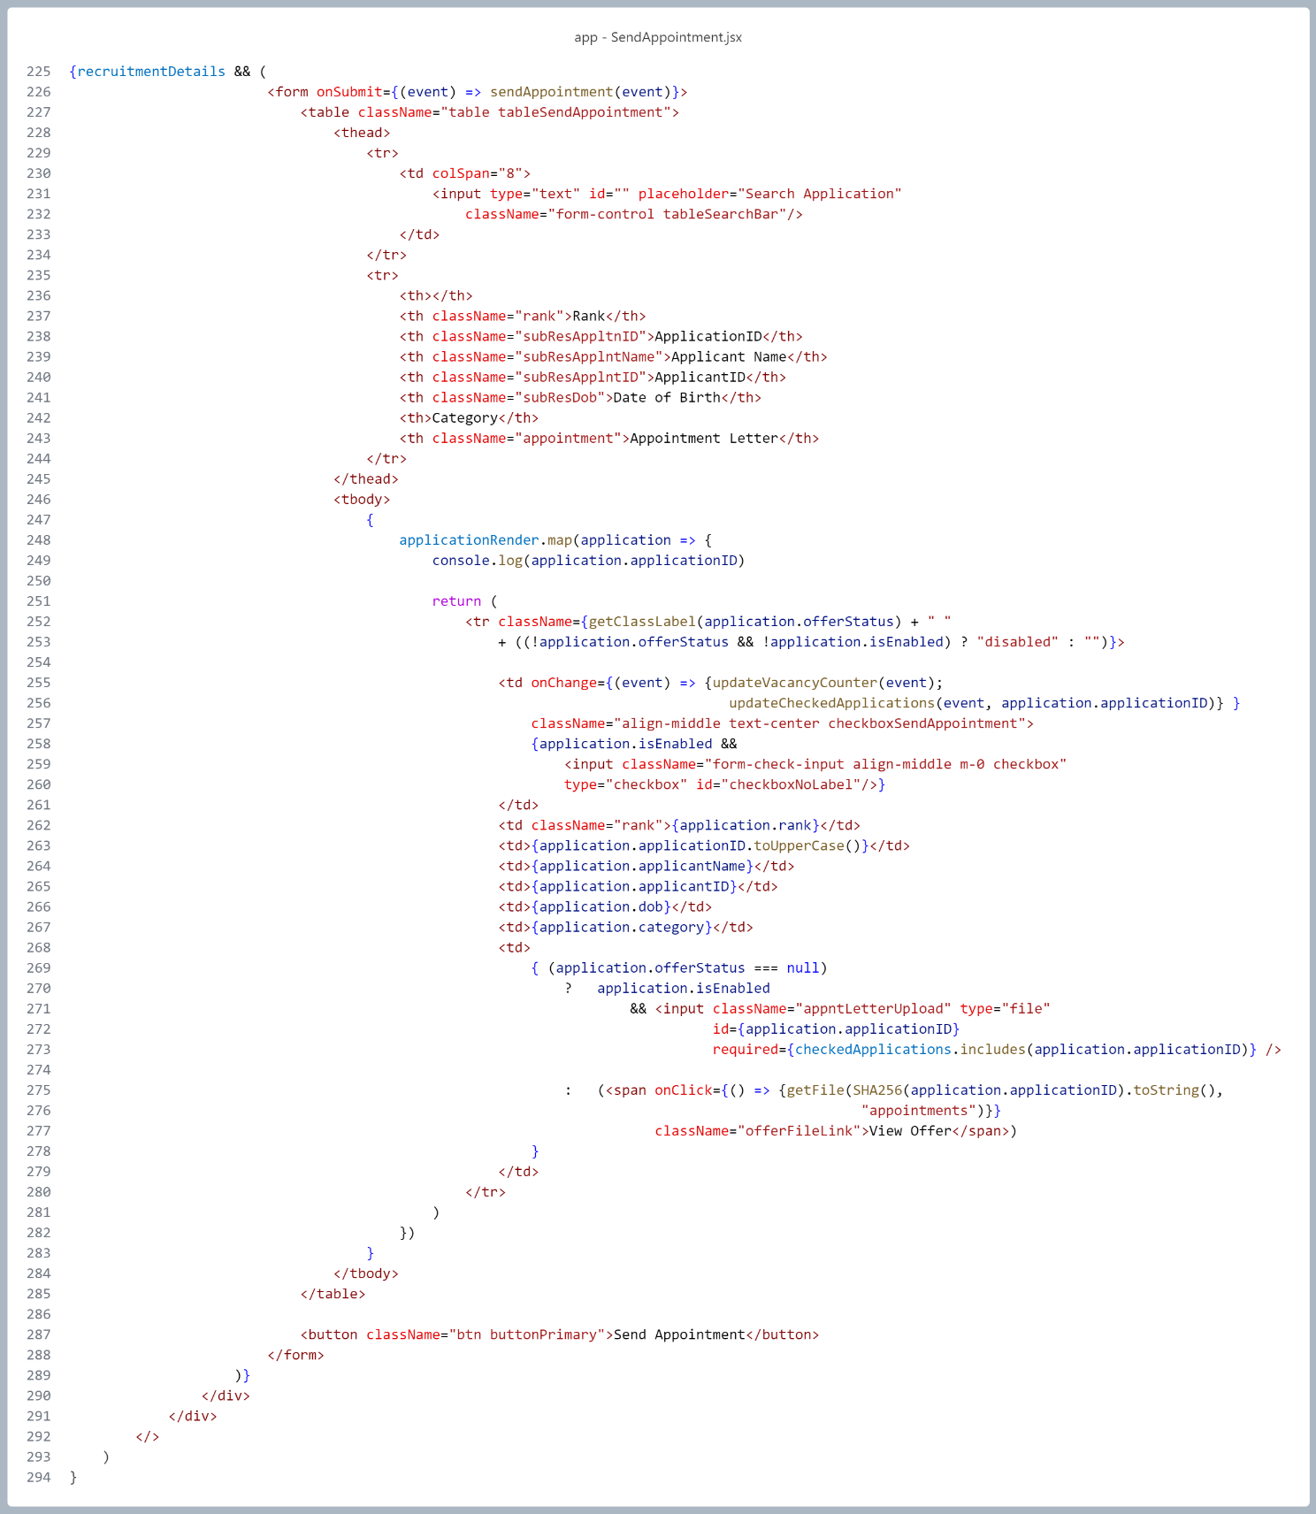

**SECURITY**

**Hashed Password Storage:**

* Passwords are **never stored in plain text**.
* They are hashed on the server side using a secure hashing algorithm like SHA-256 (ideally with salt if using SHA).
* This ensures that even if the database is compromised, raw passwords are not retrievable.

**Client-Side Validation + Server-Side Verification:**

* Input fields like usernames, passwords, emails, etc., are validated on the frontend to reduce garbage or malformed input.
* All data is re-validated on the server to prevent client-side bypass and **injection attacks**.

**Prepared Statements via PDO:**

* All interactions with MySQL are done using **PDO with prepared statements**, eliminating the risk of **SQL injection**.
* Parameters are bound securely, and user inputs are not directly inserted into SQL queries.

**Session-based Authentication (PHP Sessions):**

* On successful login, a secure PHP session is initiated to track the user instead of transmitting credentials with every request.
* Session IDs are regenerated upon login and stored securely in cookies.

**MIME Type and Extension Validation for File Uploads:**

* File uploads (e.g., documents) are strictly validated by MIME type and extension.
* This prevents malicious files from being uploaded (e.g., disguised scripts or executables).

**Access Control Logic:**

* Frontend and backend routes are protected by checking user type and session state (accType, userID, etc.).
* Users are redirected or denied access if unauthorized actions are attempted.

**Secure File Storage by Hash Name:**

* Uploaded files are renamed using **hashed filenames (documentID)** to prevent predictable URL access.
* The frontend only submits a reference hash and type (like 'appointment', 'recruitment'), and the backend resolves the path securely.

**Password Strength Enforcement:**

* Password fields are validated to ensure a minimum complexity (uppercase, lowercase, digit, special character, and minimum length).
* This mitigates **brute-force** and **dictionary attacks**.

**LIMITATIONS**

**Dependency on Electronic Devices and Internet Connectivity**

The system requires users (both applicants and recruiters) to have access to a digital device (PC, smartphone, tablet, etc.) with a stable internet connection and a modern web browser. This may limit accessibility in rural or low-connectivity areas.

**No Offline Application Support**

The system does not support offline or physical application submission, which may exclude individuals who are not digitally literate or lack access to digital infrastructure.

**No Support for Multi-Language Interfaces *(Current Version)***

The current implementation supports only English. Applicants not fluent in English may face difficulties navigating the system. Future versions may include regional language support.

**Limited Role Hierarchy and Delegation *(Current Version)***

Only a single recruiter role is currently supported. Hierarchical permissions, role-based task delegation, and third-party recruitment agency integration are scoped for future versions but are not implemented in the current release.

**Lack of Real-time Notification System *(Current Version)***

The current version lacks real-time notifications (e.g., SMS, push, or in-app notifications) for updates like rank publication or appointment issuance, which may delay user response.

**Limited Location Handling *(Current Version)***

Although future versions are planned to support multiple office locations and location preferences in application forms, this functionality is not present in the current version.

**Browser Compatibility Constraints *(Current Version)***

The system is optimized for modern web browsers like Google Chrome and Firefox. Legacy browsers or unsupported devices may not render the UI or run client-side logic properly.

**No External Identity Verification *(Current Version)***

The system does not integrate with external identity verification systems (e.g., Aadhaar, PAN). It relies on self-reported data, which must be verified manually by recruiters.

**Scalability Testing Pending**

While the system is designed for large-scale usage (millions of applicants), stress testing and performance benchmarking under peak load are yet to be conducted in a production-like environment.

**Security Features Still Evolving**

Though fundamental measures like password hashing, secure sessions, and input validation are in place, advanced security features like CAPTCHA, two-factor authentication (2FA), and login attempt rate-limiting are planned for future versions.

**REFERENCES**

1. "RRB NTPC Admit Card 2025 Out @rrbcdg.gov.in Today: Get Direct Links & Steps to Download RRB NTPC CBT 1 Hall Ticket & City Intimation." *IndiaTimes*, June 1, 2025. [indiatimes.com](https://indiatimes.com/news/education/rrb-ntpc-admit-card-2025-out-at-rrbcdggovin-today-get-direct-links-steps-to-download-rrb-ntpc-cbt-1-hall-ticket-city-intimation-660058.html?utm_source=chatgpt.com)
2. "SSC GD Constable Result 2025: Results Expected Soon for Over 53,000 Vacancies, All You Need to Know." *Economic Times*, June 3, 2025. [economictimes.indiatimes.com+1timesofindia.indiatimes.com+1](https://economictimes.indiatimes.com/news/new-updates/ssc-gd-constable-result-2025-results-expected-soon-for-over-53000-vacancies-all-you-need-to-know/articleshow/121611108.cms?utm_source=chatgpt.com)
3. "35 Candidates to Compete for Each Teacher Post Under DSC in Andhra Pradesh." *Times of India*, June 3, 2025. [timesofindia.indiatimes.com](https://timesofindia.indiatimes.com/city/vijayawada/35-candidates-to-compete-for-each-teacher-post-under-dsc-in-andhra-pradesh/articleshow/121577443.cms?utm_source=chatgpt.com)